NFC-IET UNIVERSITY, MULTAN



ICT (“Information & Communication Technology Fundamental”) For the degree of Bachelor of Science In Computer Science

Session 2K24

Name M. Usman Mubarak

Roll no (2k24-BSCS-416)

Section Y

Submitted to Mam Fabia Hassan

Submitted by M. Usman Mubarak

October 2024

**LAB 1**

 **Typing Practice:**

Typing practice is the process of repeatedly typing to improve typing speed and accuracy. It involves learning the correct finger placement on the keyboard and practicing typing without looking at the keys.

❖ **Benefits of typing practicing:**

* Increased productivity
* Reduced strain
* Improved focus
* Inhanced computer skills
* ❖ **Popular typing practicing tools:**
* Typing club
* Keyboard
* Typing.com
* Typing test.com

 **INTERNAL COMPONENTS OF COMPUTER:**

A computer is a complex machine composed of various interconnected components. Here are the primary internal components that work together to process information:

❖ **Central Processing Unit (CPU):**

* Often referred to as the "brain" of the computer.
* Executes instructions and performs calculations.
* Divided into two main units:
  + - **Control Unit (CU):** Coordinates and controls the operations of the computer.
    - **Arithmetic Logic Unit (ALU):** Performs arithmetic and logical operations.

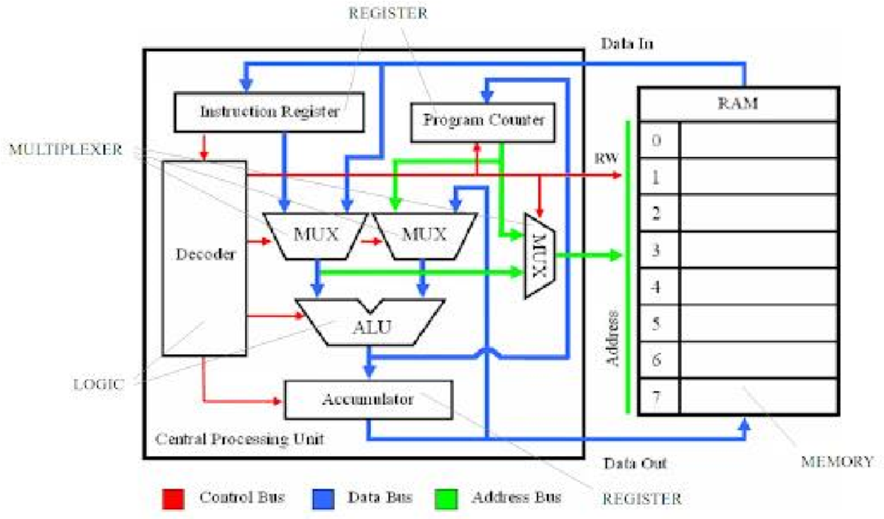

❖ **Motherboard:**

* The main circuit board that connects all the internal components.
* Provides the electrical pathways for communication between components.
* Houses various expansion slots for additional hardware.

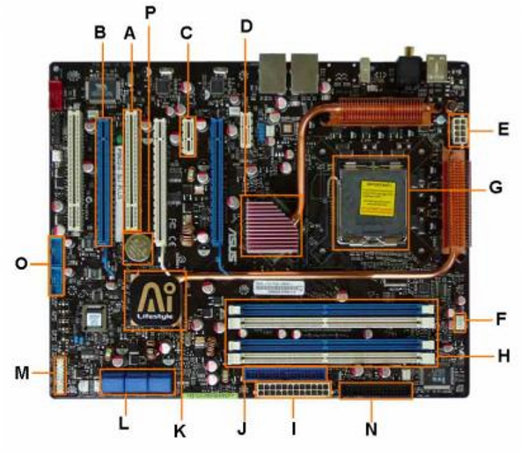

❖  **Random Access Memory (RAM):**

* Temporary storage for data and instructions that the CPU is currently using.
* Volatile memory, meaning data is lost when the power is turned off.

Random Access Memory, commonly referred to as RAM, is a critical component of modern computing systems, responsible for temporarily storing data that the CPU needs to process tasks efficiently. Its role is essential in determining the performance of devices, whether they are personal computers, smartphones, or even servers. In this comprehensive overview, we will delve into the fundamental principles of RAM, its types, operation, and significance in computing.

* What is RAM?

RAM is a type of volatile memory, meaning that it stores data temporarily and loses its content when the device is powered off. Unlike permanent storage devices like hard drives or SSDs, RAM allows for rapid access to data, enabling the central processing unit (CPU) to retrieve and process information at speeds far greater than those possible with other storage devices.

The term “random access” refers to the ability of the CPU to access any part of the memory directly and without a sequence, as opposed to sequential memory, such as magnetic tapes, where data must be accessed in order.

* How RAM Works

RAM operates by temporarily storing the data and instructions needed for active processes. For instance, when you open a web browser, the application and the webpage data are loaded into RAM to ensure fast access. When the browser is closed, the space it occupied in RAM is freed, making room for other tasks. The memory consists of microscopic capacitors and transistors. Each capacitor represents a single bit of data, either 0 or 1, and is maintained by a transistor that charges or discharges the capacitor. In dynamic RAM (DRAM), this charge needs constant refreshing because it naturally leaks away, a process that happens thousands of times per second.

* Types of RAM

RAM is categorized into various types, with the most common being DRAM (Dynamic RAM) and SRAM (Static RAM).

* 1. Dynamic RAM (DRAM)

DRAM is the most common type of RAM used in personal computers and servers.

It is called “dynamic” because it requires constant refreshing to maintain its data.

DRAM is cost-effective and offers high storage capacities but is slower compared to SRAM.

* 1. Static RAM (SRAM)

SRAM uses flip-flop circuits to store data, making it faster and more reliable than DRAM.

•It does not require refreshing, hence the term “static.”

•However, SRAM is more expensive and consumes more power, limiting its use to smaller, highspeed caches in CPUs.

* + Other specialized RAM types include:
    - SDRAM (Synchronous DRAM):

Synchronizes with the system clock for higher efficiency.

* + - DDR (Double Data Rate SDRAM):

Transfers data on both the rising and falling edges of the clock cycle, offering improved performance. Variants include DDR2, DDR3, DDR4, and DDR5, each providing increased speeds and reduced power consumption.

* + - GDDR (Graphics DDR):

A variant optimized for GPUs, designed for high bandwidth and parallel processing.

• LPDDR (Low Power DDR):

Found in mobile devices, balancing performance and power efficiency.

* + Capacity and Speed

The capacity of RAM is typically measured in gigabytes (GB) or terabytes (TB), and the speed is measured in megahertz (MHz) or gigahertz (GHz). Larger RAM capacities allow for more applications or larger datasets to be handled simultaneously, while higher speeds enable faster data retrieval and processing.

* + Role of RAM in Computing

RAM’s primary function is to act as a bridge between the CPU and permanent storage. Without sufficient RAM, the CPU would frequently access slower storage devices, leading to significant performance bottlenecks. RAM contributes to:

1.Multitasking

The ability to run multiple programs simultaneously without significant slowdowns depends on available RAM.

* 1. Speed and Responsiveness

Applications load faster, and systems operate more smoothly with adequate RAM.

* 1. Gaming and Graphics

Modern games and graphic-intensive applications demand high-capacity, high-speed RAM to handle large textures and real-time processing.

4.Data Processing

RAM is essential for scientific simulations, video editing, and other tasks requiring large datasets to be processed quickly.

* + How Much RAM Do You Need?

The amount of RAM required varies depending on the use case:

•Basic Usage (Web Browsing, Email): 4–8 GB

•Productivity (Office Applications, Light Photo Editing): 8–16 GB

•Gaming: 16–32 GB

•Content Creation (Video Editing, 3D Modeling): 32–64 GB or more

* + RAM vs. Storage

RAM is often confused with storage. While both hold data, they serve different purposes:

RAM: Temporary, fast, volatile storage used for active tasks.

Storage (HDD/SSD): Permanent, slower, non-volatile storage for long-term data retention.

For example, a computer with ample storage but insufficient RAM will struggle with performance, as tasks are repeatedly offloaded to slower storage mediums.

* + The Evolution of RAM

RAM has evolved significantly over the decades, with advancements focused on speed, capacity, and power efficiency. Key milestones include:

1.Early RAM Technologies

Core memory and magnetic drums were used in early computers.

2.Introduction of DRAM (1970s):

Provided higher capacities at lower costs.

3.Modern SDRAM and DDR Standards:

Improved synchronization and efficiency to meet the demands of modern computing.

4.Emerging Technologies:

Next-generation memory like DDR5, HBM (High Bandwidth Memory), and MRAM (Magnet resistive RAM) are designed to handle future workloads.

 Challenges:

|  |
| --- |
| ❖ While RAM technology has advanced, it faces challenges: |

1.Scaling Limits:

As circuits shrink, maintaining reliability and speed becomes harder.

2.Power Efficiency:

Essential for mobile and embedded devices to extend battery life.

3.Cost:

Higher-performance RAM can be prohibitively expensive.

Emerging innovations aim to address these challenges, such as non-volatile RAM (e.g., Intel Optane) that retains data even without power.

|  |
| --- |
| ❖ CONCLUSION: |

RAM is a cornerstone of modern computing, enabling systems to operate efficiently and handle complex tasks. Its evolution, from early DRAM to advanced DDR and specialized memory types, reflects the growing demands for speed, capacity, and energy efficiency in technology. As we move into an era of artificial intelligence, quantum computing, and immersive experiences, RAM will continue to play a pivotal role in shaping the future of computing.

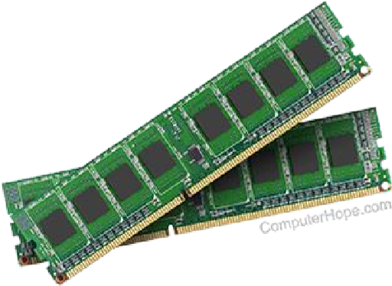

**4. Storage Devices:**

* **Hard Disk Drive (HDD):** Stores large amounts of data permanently.
* **Solid-State Drive (SSD):** Faster and more reliable than HDDs.
* **Optical Drives:** Used for reading and writing data on CDs, DVDs, or Blu- ray discs.

**Storage Devices:**

Storage devices are a fundamental component of modern computing systems, designed to store and retrieve digital information. They have evolved over the decades in terms of capacity, speed, reliability, and portability. Understanding storage devices is essential in fields ranging from personal computing to enterprise-level IT infrastructure.

❖ **Types of Storage Devices**

* Storage devices can be broadly classified into two categories:

primary storage and secondary storage.

1.**Primary Storage**

* Refers to memory devices directly accessible by the central processing unit (CPU).
* Volatile in nature, meaning data is lost when the power is turned off.
* Examples include Random Access Memory (RAM) and cache memory.

**2.Secondary Storage**

* Non-volatile, meaning data persists even without power.
* Used for long-term data storage.
* Examples include hard disk drives (HDDs), solid-state drives (SSDs), and optical media like CDs and DVDs.

* **Common Types of Storage Devices**

**1.Hard Disk Drives (HDDs)**

* **Description:** Mechanical devices that store data on spinning magnetic platters.❖ **Advantages:**

•Large storage capacity at a lower cost per gigabyte.

•Long lifespan if maintained properly.

* **Disadvantages:**

•Slower access speeds compared to modern alternatives.

•Susceptible to physical damage due to moving parts.

•Applications: Personal computers, servers, and data centers. **2.Solid-State Drives (SSDs**)

* **Description:** Storage devices with no moving parts, using NAND flash memory. ❖ **Advantages:**

•Faster read/write speeds compared to HDDs.

•More durable due to the absence of mechanical components.

•Compact and lightweight.

* **Disadvantages:**

•Higher cost per gigabyte compared to HDDs.

• Limited write cycles, though modern advancements have significantly mitigated this.

* **Applicatio**ns:

Laptops, smartphones, high-performance gaming, and enterprise servers.

3.**Optical Storage**

* **Description:**

Devices like CDs, DVDs, and Blu-rays that use lasers to read and write data.

* **Advantages:**

•Cheap and widely available.

•Ideal for archiving and distribution of media.

* **Disadvantages:**

•Slower access speeds compared to HDDs and SSDs.

•Limited storage capacity.

* **Applications:** Software distribution, movies, and backups.

**4.Flash Drives**

* **Description:**

Portable storage devices using NAND flash memory, often connected via USB.

* **Advantages:**

•Highly portable and durable.

•Plug-and-play functionality.

* **Disadvantages:**

•Limited storage capacity compared to SSDs and HDDs.

•Performance varies based on USB interface (e.g., USB 2.0 vs. USB 3.0).

•Applications: Personal data transfer, portable backups.

**5.Memory Cards**

* **Description:**

Compact storage media used in devices like cameras, smartphones, and gaming consoles.

* **Advantages:**

•Small size and lightweight.

•Compatibility with a wide range of devices.

* **Disadvantages:**

•Easy to lose due to their small size.

•Limited storage compared to HDDs and SSDs.

* **Applications:**

Photography, mobile storage, and IoT devices.

**Diagram of storage devices:**

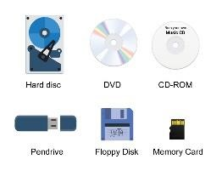

6.**Network Attached Storage (NAS)** ❖ **Description:**

* Centralized storage accessible via a network, often used in homes and businesses. **Advantages:**

•Supports multiple users and devices.

•Allows for remote access and backup.

* **Disadvantages:**

•Requires network infrastructure.

•Initial setup can be complex for non-technical users.

* **Applications:** Home media servers, small business data storage.

7.**Cloud Storage**

•Description: Online storage provided by third-party providers, accessible via the internet.

* **Advantages:**

•Accessible from anywhere with an internet connection.

•No need for physical hardware.

* **Disadvantages:**

• Ongoing subscription costs for larger storage.

* **Applications:**

Backup solutions, file sharing, and collaborative work.

* **Key Factors to Consider When Choosing a Storage Device**

1.**Capacity**

•Determines the amount of data the device can store.

•HDDs and cloud storage are ideal for large capacities, while flash drives and memory cards suit smaller requirements.

2.**Speed**

•SSDs provide faster data access compared to HDDs and optical media.

•Essential for applications like video editing and gaming.

3.**Portability**

•Devices like flash drives and memory cards are lightweight and portable.

•NAS and cloud storage are better for static environments with network access. 4.**Durability**

•SSDs and flash-based storage are more resistant to physical shocks than HDDs.

•Optical media is prone to scratches, and HDDs are sensitive to drops.

5**.Cost**

•HDDs and optical storage are more affordable for large-scale storage needs.

•SSDs and cloud storage are costlier but offer enhanced performance.

6.**Use Case**

•Specific needs dictate the ideal storage device. For instance:

•Cloud storage is best for remote access.

•SSDs are ideal for speed-intensive tasks.

❖ **The Evolution of Storage Devices**

The history of storage devices reflects advancements in technology and user demands.

1.**Magnetic Tape (1950s)**

•One of the earliest forms of digital storage.

•Still used today for archival purposes due to its cost-effectiveness.

2.**Floppy Disks (1970s-1990s)**

•Widely used for personal data storage.

•Replaced by higher-capacity and more durable devices.

3.**Hard Disk Drives (1980s-Present**) •Continually improved in capacity and speed.

•Remain a staple in modern computing.

4.**Optical Media (1990s-2010s)**

•Initially revolutionary, now declining due to the rise of flash-based and cloud storage.

5.**Solid-State Drives (2000s-Present)**

•Represent the future of storage with unparalleled speed and efficiency.

•Rapidly becoming the standard in both personal and enterprise computing.

6.**Cloud Storage (2010s-Present**)

•A paradigm shift toward remote, scalable, and collaborative storage solutions.

•Continues to grow with advancements in internet technology. Future Trends in Storage Devices

1.**Increased Capacity and Speed**

•Technologies like 3D NAND and NVMe SSDs promise even faster and larger storage options.

2.**AI and Machine Learning Integration**

•Smart storage devices that optimize performance based on usage patterns.

3.**Energy Efficiency**

•New designs focus on reducing power consumption, especially in data centers.

4.**Quantum Storage**

•Emerging technology that may revolutionize data storage by leveraging quantum mechanics.

5.**Decentralized Storage**

•Blockchain-based systems like IPFS (InterPlanetary File System) offer secure and distributed storage solutions.

❖ **Conclusion**

Storage devices play a crucial role in every aspect of modern life, from personal computing to global business operations. As technology advances, storage devices will continue to evolve, offering faster, larger, and more efficient solutions to meet the ever-growing demands of the digital age. By understanding the types, uses, and trends in storage technology, users can make informed decisions to optimize their data management needs.

**5. Power Supply Unit (PSU):**

Converts AC power from the wall outlet to DC power for the

computer's components. The Power Supply Unit (PSU) is a crucial component in any

electronic system, particularly in computers. It serves as the primary source of electrical power for all internal components by converting electricity from an external source into usable voltage and current levels. This document provides an in-depth understanding of PSUs, their importance, types, functions, and factors to consider when choosing one.

❖ **What is a Power Supply Unit?**

A PSU is a device that provides power to the internal components of a system, such as the motherboard, CPU, graphics card, storage drives, and peripherals. It ensures that these components receive stable and appropriate voltages for optimal performance and reliability. Without a functioning PSU, no electronic device, including computers, can operate.

❖ **Functions of a PSU**

**1.Conversion of Power**

•Converts Alternating Current (AC) from the mains supply into Direct Current (DC) required by most electronic components.

**2.Voltage Regulation**

•Ensures a consistent and stable voltage supply, protecting components from fluctuations that could cause damage.

**3.Power Distribution**

•Divides power among the system components, providing appropriate voltages such as 3.3V, 5V, and 12V.

**4.Efficiency**

•Determines how much power is wasted during conversion. Efficient PSUs waste less energy as heat and reduce electricity costs.

**5.Protection Mechanisms**

•Offers safety features like over-voltage, under-voltage, over-current, and short-circuit protection to safeguard components.

|  |
| --- |
| ❖ **Types of PSUs:** |

**1.Linear Power Supply**

•Description: Uses transformers to step down voltage and rectifiers to convert AC to DC.

* **Advantages:**

•Simpler design and robust performance.

* **Disadvantages:**

•Large size and heavy weight.

•Inefficient for high-power applications.

•Applications: Low-power systems and some industrial devices.

**2.Switching Power Supply**

•Description: Uses high-frequency switching to convert power efficiently.

* **Advantages:**

•High efficiency and compact size.

* **Disadvantages:**

•More complex circuitry.

•Generates electrical noise.

•Applications: Modern computers, telecommunications, and portable electronics.

**3.Uninterruptible Power Supply (UPS**)

•Description: Provides backup power and voltage regulation during outages or surges.

* **Advantages:**

•Prevents system shutdown during power failures.

* **Disadvantages:**

•Expensive compared to regular PSUs.

•Applications: Critical systems like servers and medical devices.

* **Key Specifications of a PSU**

**1.Wattage**

•Indicates the total power the PSU can deliver.

•Typical ranges are from 300W for basic systems to 1500W for high-performance gaming or workstation setups.

**2.Efficiency Ratings**

•Measured by the 80 PLUS Certification:

•Standard, Bronze, Silver, Gold, Platinum, and Titanium tiers.

•Higher ratings mean less energy wasted as heat.

•Example: An 80 PLUS Gold PSU is 87% efficient at 100% load.

**3.Form Factor**

•Refers to the physical size and mounting compatibility with a case.

•Common types include:

**•ATX:** Standard size for most desktop PCs.

**•SFX:** Smaller form factor for compact builds.

**•TFX:** Thin PSUs for specialized cases.

**4.Modularity**

•Non-Modular PSUs: Fixed cables, cost-effective but less flexible.

•Semi-Modular PSUs: Some detachable cables, balance of cost and convenience.

•Fully Modular PSUs: All cables are detachable, making cable management easier. **5.Rails**

•Refers to the distribution of 12V power:

•Single-Rail PSU: All components draw from the same 12V rail.

•Multi-Rail PSU: Multiple 12V rails for better load balancing and safety.

❖ **Components of a PSU**

**1.Transformer**

•Steps down the high voltage from the mains supply to usable levels.

**2.Rectifier**

•Converts AC into DC using diodes.

**3.Capacitors**

•Smoothens out fluctuations and stabilizes the output voltage.

**4.Voltage Regulator**

•Maintains consistent output voltage under varying loads.

**5.Cooling Mechanism**

•Includes fans or passive cooling systems to dissipate heat generated during operation.

**6.Connectors**

•Provide power to components. Common types include:

**•24-pin ATX connector:** For the motherboard.

**•8/4-pin EPS connector:** For the CPU.

**•PCIe connectors:** For GPUs.

**•SATA and Molex connectors:** For storage drives and peripherals.

❖ **Choosing the Right PSU**

Selecting the right PSU is essential to ensure system stability, longevity, and efficiency. Consider the following❖ **factors:**

**1.Power Requirements**

•Calculate the total wattage of all components, adding a margin for future upgrades. **2.Efficiency**

•Choose a PSU with an 80 PLUS certification to reduce energy costs and heat output.

**3.Build Quality**

•Opt for reputable brands with high-quality components for reliability.

**4.Noise Levels**

•Look for PSUs with silent or semi-passive cooling designs to minimize noise.

**5.Future-Proofing**

•Consider a higher wattage PSU for potential component upgrades.

**6.Budget**

•Balance cost with features. A PSU is a long-term investment, so avoid skimping on quality.

* **Common Issues and Maintenance**

**1.Signs of a Failing PSU**

**•Random system shutdowns** or reboots.

•Unusual noises like clicking or buzzing.

•Overheating and burnt smells.

2**.Maintenance Tips**

•Clean dust and debris regularly to prevent overheating.

•Ensure proper airflow and avoid blocking vents.

•Use a surge protector to safeguard against power spikes

**Diagram:**

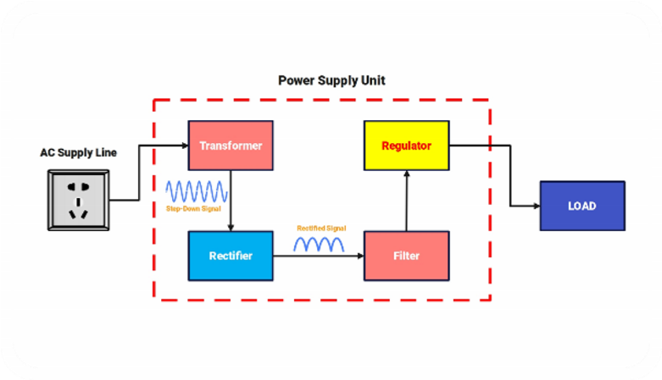

* **PSU Efficiency and Environmental Impact**

Efficiency plays a critical role in reducing energy consumption and environmental impact. A highefficiency PSU generates less heat, reducing the need for excessive cooling. Governments and organizations are encouraging energy-efficient PSUs to lower carbon footprints.

* **Future Trends in PSU Technology**

**1.Higher Efficiency Standards**

•New certifications aiming for near-zero power wastage.

**2.Smarter PSUs**

**•**Integration with system monitoring tools for real-time power management.

**3.Compact Designs**

•Advances in component miniaturization to fit smaller systems.

**4.Renewable Energy Compatibility**

•PSUs designed to work with alternative energy sources like solar panels.

* **Conclusion**

The Power Supply Unit is a critical component that directly impacts the performance, stability, and longevity of electronic systems. Understanding its features, specifications, and functionality is key to building and maintaining a reliable system. By selecting a high-quality, efficient PSU tailored to specific needs, users can ensure optimal performance while minimizing energy consumption and environmental impact.

**6. Cooling System:**

* Dissipates heat generated by the CPU and other components.
* Typically includes a fan and heat sink.

**7. Input/Output Devices:**

* **Input Devices:**
  + **Keyboard:** For entering text and commands. o **Mouse:** For navigating the user interface.
  + **Scanner:** For converting physical documents into digital images.
  + **Microphone:** For capturing audio input.
* **Output Devices:**
  + **Monitor:** Displays visual information. o **Printer:** Produces physical copies of documents.
  + **Speakers:** Outputs audio.

❖ **Visual Representation:**

A computer is a complex machine composed of various interconnected components. Here are the primary internal components that work together to process information.

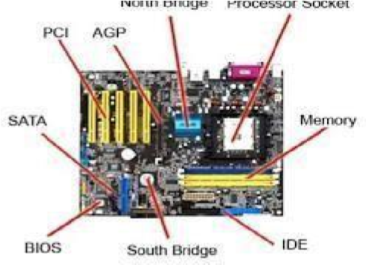

* computer motherboard with labeled components
* By understanding these components and their functions, you can better appreciate the intricate workings of a computer.

LAB 2  **Window installation process:**

Here's a general overview of the window installation process. Specific steps may vary depending on the type of window and installation method:

➢ **Preparation:**

1. **Measure and Order:** Accurately measure the window opening to determine the correct size and type of window. Order the windows from a supplier or retailer.
2. **Remove Old Window:** Carefully remove the old window frame, ensuring that the rough opening is clean and free of debris.
3. **Prepare the Opening:** If necessary, adjust the rough opening to accommodate the new window frame. Ensure the opening is level and plumb.

➢ **Installation:**

**1. Install the Frame:**

o Position the new window frame in the rough opening, ensuring it's level and plumb. o Secure the frame using shims to maintain proper alignment. o Fasten the frame to the wall studs using screws or nails, depending on the material of the frame and wall.

ools and Materials Needed

1. **Tools**

•Drill or screwdriver

•Level

•Measuring tape

•Hammer

•Pencil or marker

•Stud finder (optional, for heavier frames)

1. **Materials**

* Nails or screws
* Wall anchors (for heavier frames)
* Picture hooks or hanging wire
* Adhesive strips (optional, for lightweight frames)

**Step 1: Plan the Placement**

**1.Determine the Location**

•Decide where the frame will be installed. Consider factors like wall space, surrounding decor, and lighting.

•For aesthetic balance, the center of the frame should ideally be at eye level, approximately 57–60 inches from the floor.

***2.*Mark the Wall**

•Use a pencil to mark the desired location of the top edge or the center of the frame.

**Step 2: Prepare the Frame**

1.Check the Hanging Mechanism

•Frames may come with built-in hooks, D-rings, or hanging wires. Ensure these are securely attached.

•For frames without hanging hardware, install a wire or hooks on the back of the frame.

2.Measure the Hardware Position

•Measure the distance between the top edge of the frame and the hanging point(s). This will guide where you place nails or hooks on the wall.

**Step 3: Prepare the Wall**

**1.Locate Wall Studs (Optional**)

•For heavy frames, use a stud finder to locate wall studs for added support.

•If no studs are available, use wall anchors to secure the frame.

**2.Mark the Nail/Screw Position**

•Transfer the measurements of the hanging hardware from the frame to the wall.

•Use a level to ensure the marks are straight.

Step 4: Install the Frame

**1.Lightweight Frames**

•Use adhesive strips or small nails for lightweight frames. •Press firmly if using adhesive strips, following the manufacturer’s instructions.

**2.Medium-Weight Frames**

•Hammer nails or install screws into the wall at the marked positions.

•Attach hooks if necessary.

**3.Heavy Frames**

•Drill pilot holes for wall anchors.

•Insert the anchors and then screw in heavy-duty screws or hooks.

Step 5: Hang and Align the Frame

**1.Hang the Frame**

•Place the frame’s hanging hardware onto the nails, screws, or hooks.

•For frames with a wire, center the wire on the hook or nail to ensure the frame hangs evenly.

**2.Check for Levelness**

•Use a level to ensure the frame is straight.

•Adjust as necessary by shifting the frame slightly.

Step 6: Secure the Frame (Optional)

1.Prevent Shifting

•Use adhesive bumpers or small rubber pads on the back corners of the frame to keep it in place and protect the wall.

•For very heavy frames, consider additional wall anchors at the bottom edge for added stability.

❖ **Tips for Different Types of Frames**

1.**Gallery Walls**

•Plan the layout on the floor before transferring it to the wall. •Use painter’s tape to create an outline of the arrangement on the wall.

2.**Mirrors**

•Use heavy-duty anchors and ensure the wall can support the mirror’s weight.

•Mirrors often require two hooks for balanced hanging.

3.**Large Frames**

•Enlist help to hold and position the frame during installation.

•Use two hooks or nails for stability.

4.**Frames on Drywall**

•Avoid using just nails for heavy frames; wall anchors are essential.

•Consider toggle bolts for extremely heavy items.

**Maintenance**

•Periodically check the frame’s stability.

•Tighten screws or replace hardware if needed.

•Clean the frame and wall area to prevent dust buildup.

By following these steps, you can securely and neatly install a frame, enhancing the aesthetics of your space while ensuring it stays safely in place.

1. **Seal the Frame:** 
   * Apply a bead of caulk or weatherstripping around the perimeter of the frame to seal any gaps.
   * Ensure a tight seal to prevent air leaks and water infiltration.
2. **Install the Window Sashes:** 
   * Insert the window sashes into the frame, ensuring they operate smoothly.
   * Adjust the sash hardware as needed.
3. **Finish the Installation:** 
   * Remove any excess caulk or weatherstripping.
   * Install any additional hardware, such as window locks or handles.
   * Clean up the installation area, removing any debris.  **CPU assembling:**

CPU assembling refers to the process of physically installing a CPU (Central Processing Unit) onto a motherboard. It's a crucial step in building or upgrading a computer. **DIAGRAM:**

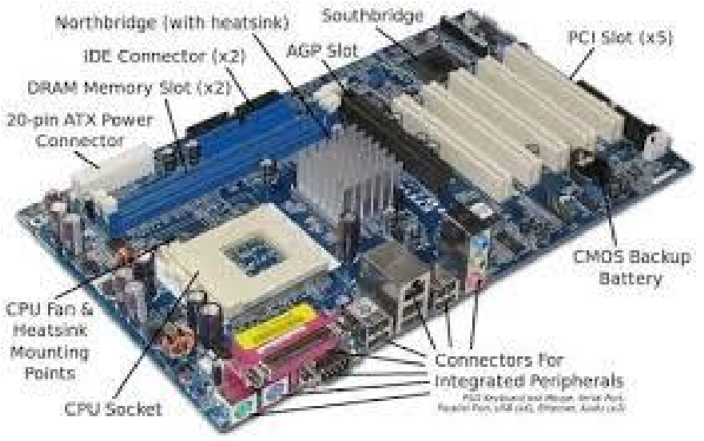

**Here's a general overview of the CPU assembly process:**

* + **Prepare the Motherboard:**

Ensure the motherboard is clean and free of any debris. Locate the CPU socket on the motherboard. It's usually a square or rectangular socket with a protective cover.

* + **Install the CPU:**

Carefully remove the protective cover from the CPU socket. Align the notches on the CPU with the corresponding keys on the socket.

Gently lower the CPU into the socket.

Close the socket lever or latch to secure the CPU in place.

* + **Apply Thermal Paste:**

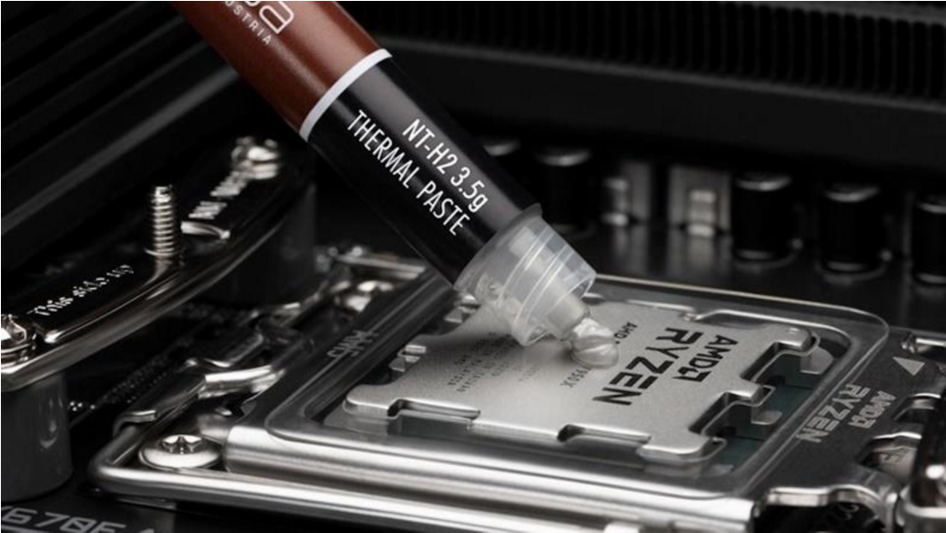

Apply a small, pea-sized amount of thermal paste to the center of the CPU. Thermal paste helps to transfer heat from the CPU to the CPU cooler, preventing overheating.

* + **Install the CPU Cooler:**

Align the mounting brackets of the CPU cooler with the corresponding holes on the motherboard.

Secure the cooler using the provided screws or clips.

Connect the power cable from the CPU cooler to the motherboard.

LAB 3

 **Motherboard:** (The Backbone of Your Computer)

A motherboard, often referred to as the mainboard or system board, is the primary circuit board within a computer. It houses and interconnects all the crucial components, enabling them to communicate and function together.

➢ **Key Components of a Motherboard:**

1. **CPU Socket:** This is where the Central Processing Unit (CPU) is installed. The socket type determines the compatible CPUs.
2. **RAM Slots:** These slots hold Random Access Memory (RAM) modules, which serve as short-term memory for the system.
3. **Chipset:** This integrated circuit controls the communication between the CPU, RAM, and other components. It's typically divided into the Northbridge and Southbridge chipsets.
4. **Expansion Slots:** These slots allow you to add expansion cards like graphics cards, sound cards, or network cards.
5. **BIOS Chip:** The Basic Input/Output System (BIOS) is a firmware that initializes the hardware components during the boot process.
6. **Power Supply Connector:** This connector supplies power to the motherboard and its components.
7. **Storage Device Connectors:** These connectors allow you to connect hard drives, SSDs, and other storage devices.
8. **I/O Ports:** These ports provide connectivity for various devices like keyboards, mice, USB drives, and external monitors.
9. **Heat Sink and Fan:** These components help dissipate heat generated by the CPU and other components.  **Visual Representation:**

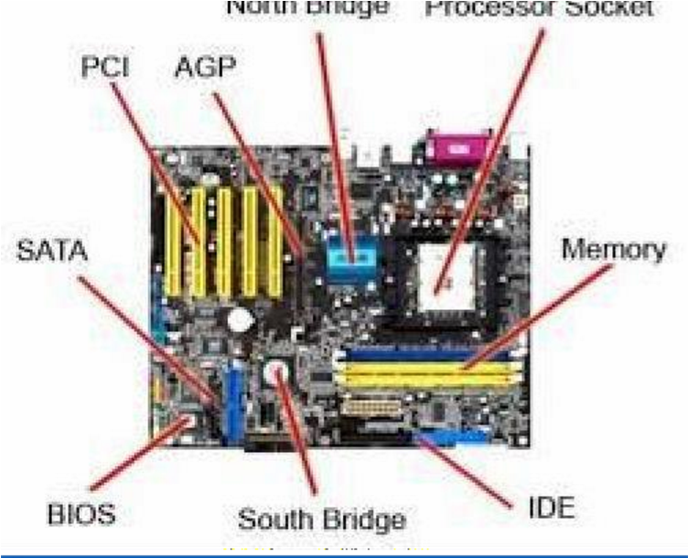

motherboard with labeled

components

➢ **How it Works:**

The motherboard acts as a central hub, facilitating communication between different components through a network of electrical pathways. When you turn on your computer, the BIOS initializes the hardware, loads the operating system, and transfers control to it. The CPU then executes instructions, processes data, and interacts with other components through the chipset.

○ **Choosing a Motherboard:**

When selecting a motherboard, consider the following factors:

* + **Socket Compatibility:** Ensure it supports your desired CPU.
  + **RAM Compatibility:** Check the supported RAM types and maximum capacity.
  + **Expansion Slots:** Consider your future needs for additional cards.
  + **Chipset:** A powerful chipset can improve overall performance.
  + **Form Factor:** Choose a size that fits your case (e.g., ATX, MicroATX, Mini-ITX).
  + **I/O Ports:** Select a motherboard with the necessary ports for your peripherals.
  + **Von neuman architecture:**
  + It was proposed by 1945

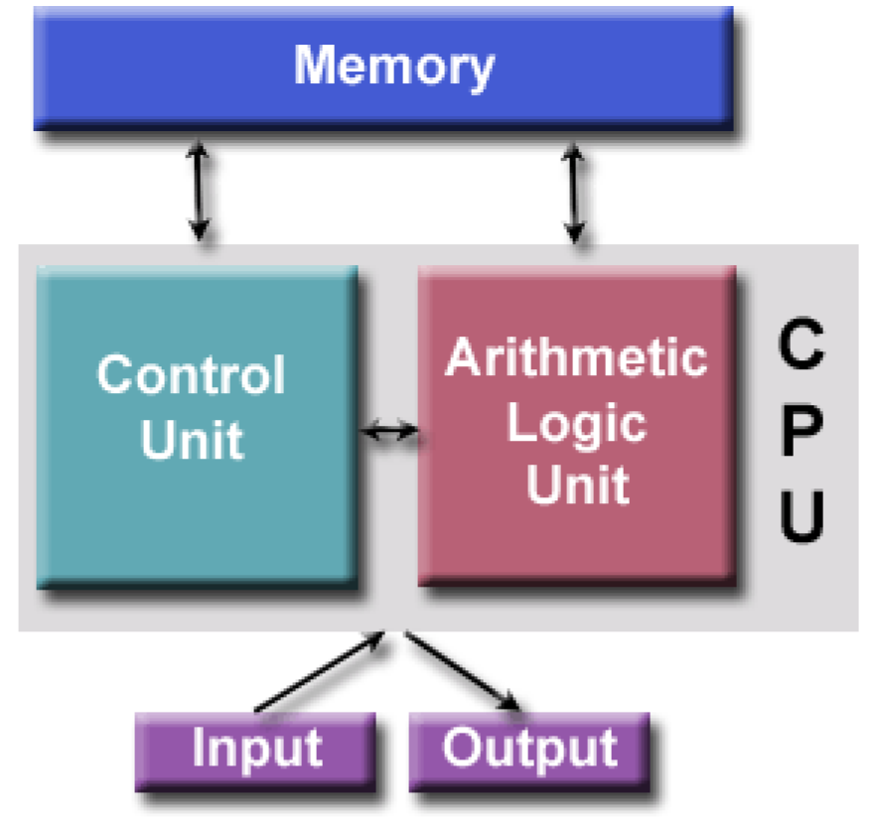

**Static Electricity:** Always ground yourself before handling computer components to avoid electrostatic discharge, which can damage sensitive components.

* + **Thermal Paste:** Use a high-quality thermal paste and apply it correctly to ensure efficient heat dissipation.
  + **CPU Cooler:** Choose a CPU cooler that is compatible with your CPU and motherboard.
  + **Motherboard Manual:** Refer to your motherboard's manual for specific instructions on CPU installation and cooler mounting.

|  |
| --- |
| ❖ **Diagram:** |

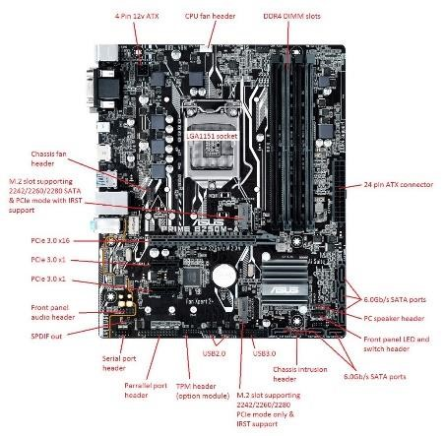

LAB 4  **Introduction to MS office:**

* + Microsoft Office is a suite of productivity applications developed by Microsoft. It's widely used in both personal and professional settings to create and edit documents, spreadsheets, presentations, and more.

➢ **Key Components of Microsoft Office:. Microsoft Word:**

* + A word processor used for creating and editing text documents. o You can format text, insert images, create tables, and much more. o Microsoft Word is a widely used word processing software developed by Microsoft. It allows users to create, edit, format, and print documents such as reports, letters, and resumes.

➢ **Features of Microsoft Word**:

Home, Insert, Design, Layout, Reference, Mailings, Review, View.

❖ **Uses of Microsoft Word:**

* + \***Document Creation\*** Letters, Reports, CV Resumes, Essays, o

Brochures, Newsletters, Meeting Agendas, Minutes, Proposals, Flyers, Invoices, Forms, Labels, Calendars, E-books, Templates, Web Pages, Books, Diaries and Journals & Scripts.

**\*Home Tab\***

**\*Clipboard*:** Cut, copy, paste, format painter.

**\*Font*:**

Font style, size, bold, italic, underline, text color, highlighting.

**\*Paragraph*:**

Alignment, indentation, line spacing, lists

(bulleted/numbered), borders.

\***Styles*:**

Quick Styles, apply styles to text**.**

**\*Editing*:**

Find, replace, select.

* Uses: Basic text formatting and editing.
* Key **Features:**
* **Clipboard**:

Cut (Ctrl + X), Copy (Ctrl + C), Paste (Ctrl + V).

* **Font:** Bold (Ctrl + B), Italic (Ctrl + I), Underline (Ctrl + U).
* **Paragraph:** Align Left (Ctrl + L), Center (Ctrl + E), Right (Ctrl + R), Justify (Ctrl + J), Increase Indent (Ctrl + M), Decrease Indent (Ctrl + Shift + M). o • **Styles:** Apply quick styles using keyboard shortcuts (e.g., Heading 1: Ctrl + Alt + 1).
* **Shortcuts:**
* Format Painter (Ctrl + Shift + C, Ctrl + Shift + V).

\***Insert Tab* *Pages*:** Cover page, blank page, page break.

\***Tables*:** Insert tables, table styles.

**\*Illustrations*:** Insert pictures, shapes, icons, 3D models, screen shots.

**\*Links*:** Hyperlink, bookmarks, cross references**.**

**\*Header & Footer*:** Insert/edit headers/footers, page numbers**.**

**\*Text*:** Insert text boxes, WordArt, signatures, equations, symbols.

**\*Media*:** Insert online videos**.**

* **Uses:** Adding various elements to a document. ➢ **Key Features:**
* **Pages:** Insert Cover Page.
* • **Tables:** Insert Table (Alt + N, T). •

**Illustrations:** Insert Picture (Alt + N, P), Insert Shape (Alt + N,

S).

* **Links:** Hyperlink (Ctrl + K).
* **Shortcuts:** • Insert Page Break (Ctrl + Enter). **\*Design Tab\***

**\*Document Formatting*:**

Themes, colors, fonts, effects.

\***Page Background**\*: Watermark, page color, page borders.

**\*Document Formatting*:** Style sets.

* **Uses:** Formatting the overall document design.
* **Key Features:**
* **Document Formatting:** Change Themes (Alt + G, H).
* **Page Background:** Watermark (Alt + G, B, W).
* **Shortcuts:** Not many shortcuts, mostly accessed via the ribbon. **\*Layout Tab\***

**\*Page Setup*:** Margins, orientation, size, columns. paragraph Indentation and spacing settings.

**\*Arrange*:** Position, wrap text, bring forward/send backward for overlapping objects**.**

* **Uses:** Page layout and settings.
* **Key Features**:
* **Page Setup:** Margins (Alt + P, M), Orientation (Alt + P, O). • **Paragraph**: Spacing settings (Alt + P, A). • Shortcuts: • Open Page Setup Dialog (Alt + P, S, P).

**\*References Tab\***

**\*Table of Contents*:** Insert, update, and customize TOC.

**\*Footnotes*:** Insert footnotes and endnotes.

**\*Citations & Bibliography*:** Manage sources, insert citations, create bibliography.

**\*Captions*:** Insert captions for figures and tables.

**\*Index*:** Mark entries and insert an index.

* **Uses**: Creating citations and references.
* **Key Features:**
* **Table of Contents:** Insert TOC (Alt + S, T).
* **Citations & Bibliography:** Insert Citation (Alt + S, C).

**\*Mailings Tab\***

**\*Create*:** Start mail merge, select recipients**.**

**\*Write & Insert Fields*:** Insert merge fields into documents.

**\*Preview Results*:** View merged documents.

**\*Finish*:** Complete and print the merged documents. **\*File Tab*:** Access to Backstage view for file management (new, open, save, print).

**\*Contextual Tabs*:** Appear when certain objects (like images, tables, charts) are selected, offering specific tools related to that object. • **File Tab:** Access Backstage view. Shortcuts: New Document (Ctrl + N), Open Document (Ctrl + O), Save Document (Ctrl + S), Print (Ctrl + P).

1. **Microsoft Excel:** 
   * A spreadsheet application for organizing and analyzing data.
   * You can perform calculations, create charts, and analyze trends.
2. **Microsoft PowerPoint:** 
   * A presentation software used to create slideshows. o You can add text, images, videos, and animations to your presentations.
3. **Microsoft Outlook:** 
   * A personal information manager used for email, calendar, and contact management.
4. **Microsoft OneNote:** o A digital notebook for capturing notes, ideas, and information.
5. **Microsoft Access:** 
   * A database management system for creating and managing databases.

➢ **Why Use Microsoft Office?**

* **Efficiency:** It streamlines tasks and improves productivity.
* **Collaboration:** It allows for easy sharing and collaboration on documents.
* **Versatility:** It can be used for a wide range of tasks, from simple to complex.
* **Professionalism:** It helps create polished and professional documents.

➢ **Getting Started with Microsoft Office:**

* 1. **Installation:** Download and install the Microsoft Office suite on your computer.
  2. **Basic Interface:** Familiarize yourself with the ribbon interface, which contains all the tools and commands.
  3. **Common Tasks:** Learn basic tasks like creating new documents, formatting text, inserting images, and saving files.
  4. **Advanced Features:** Explore advanced features like using formulas in Excel, creating custom templates in Word, and designing complex presentations in PowerPoint.

➢ **Continuous Learning:**

Microsoft Office is constantly evolving, so it's important to stay updated with the latest features and best practices. Online tutorials, courses, and Microsoft's official documentation can help you improve your skills. By mastering Microsoft Office, you can enhance your productivity and achieve your goals.

**Ms word basic features:**



Here are some of the basic features of **Microsoft Word:**

Mail merge is a powerful feature used in word processing and spreadsheet applications to automate the creation of personalized documents such as letters, emails, labels, and envelopes. By integrating data from a source (e.g., a spreadsheet or database) into a template document, mail merge simplifies and streamlines the process of creating customized communication for large audiences. Here are the primary benefits of using mail merge:

**1. Time Efficiency**

* **Streamlined Process**:

Mail merge automates the process of personalizing individual letters or emails by inserting specific data fields (like names, addresses, or order details) into a template.

* **Bulk Processing**:

Instead of manually creating each document or email, a single template and data file can generate hundreds or thousands of personalized outputs, saving significant time.

➢ **Text Formatting:**

* **Font:** Change the font type, size, color, and style (bold, italic,

underline) of text.

**Example:**

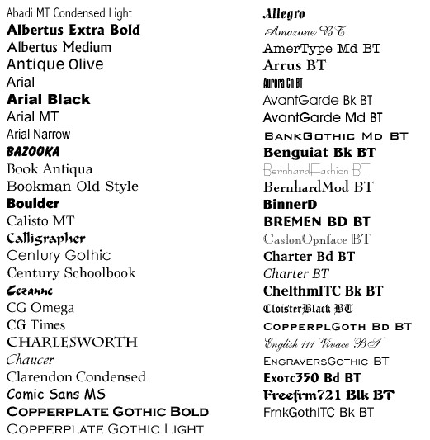

* **Alignment:** Align text to the left, right, center, or justify.

* **Example:**

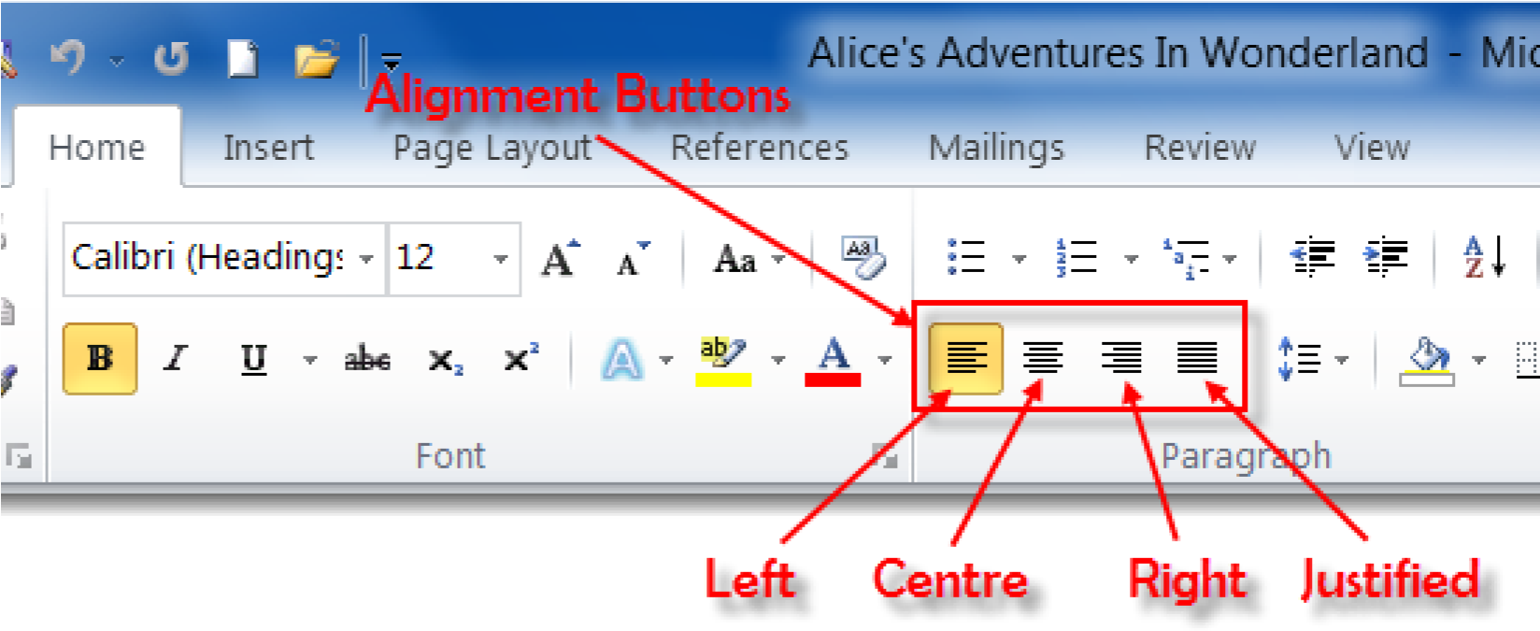

* **Line Spacing:** Adjust the spacing between lines of text **Example:**

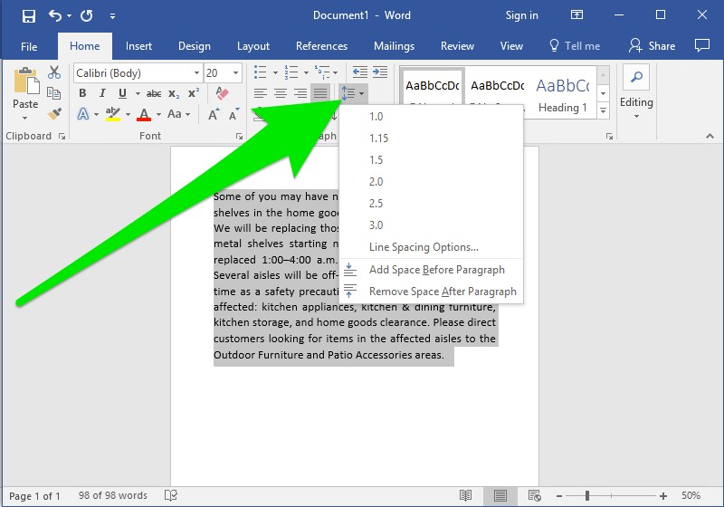

* **Paragraph Indentation:** Indent paragraphs for better organization. **Example:**

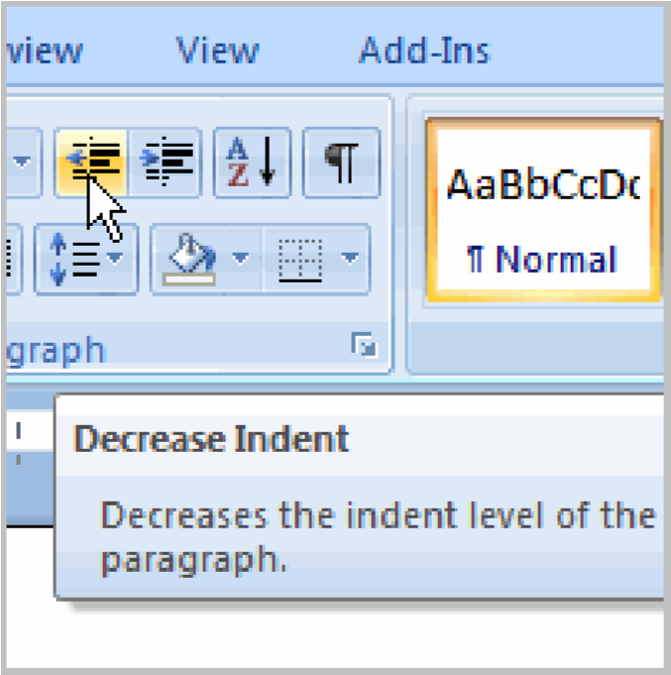

**Bullet Points and Numbering:** Create lists with bullet points or numbers **Example:**

* 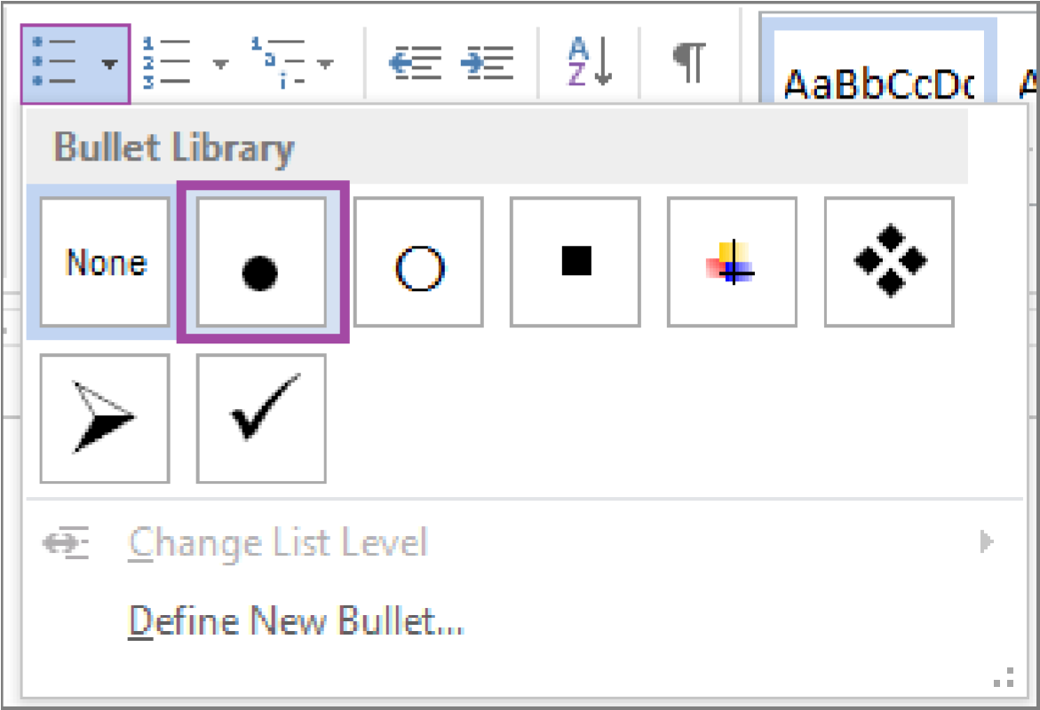

**Document Layout:**

* **Margins:** Set the margins around the document.

**Example:**

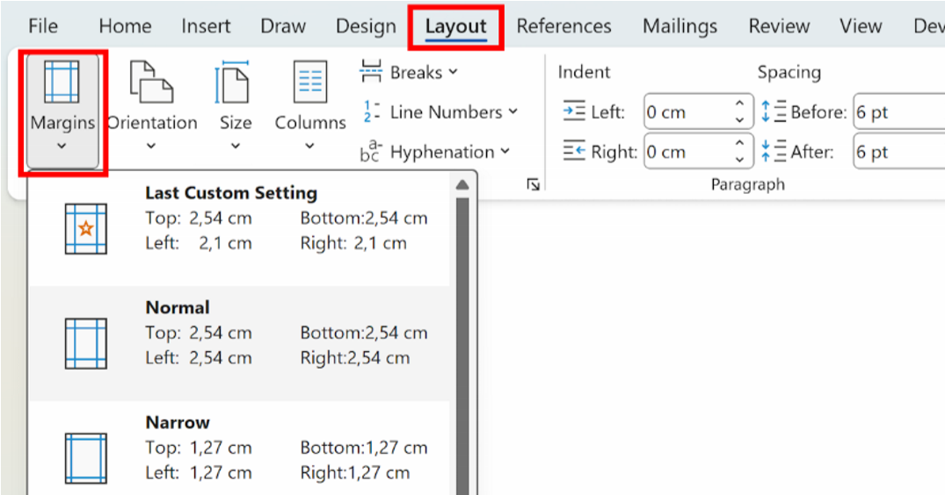

**Page Orientation:** Choose between portrait and landscape orientation. **Example:**

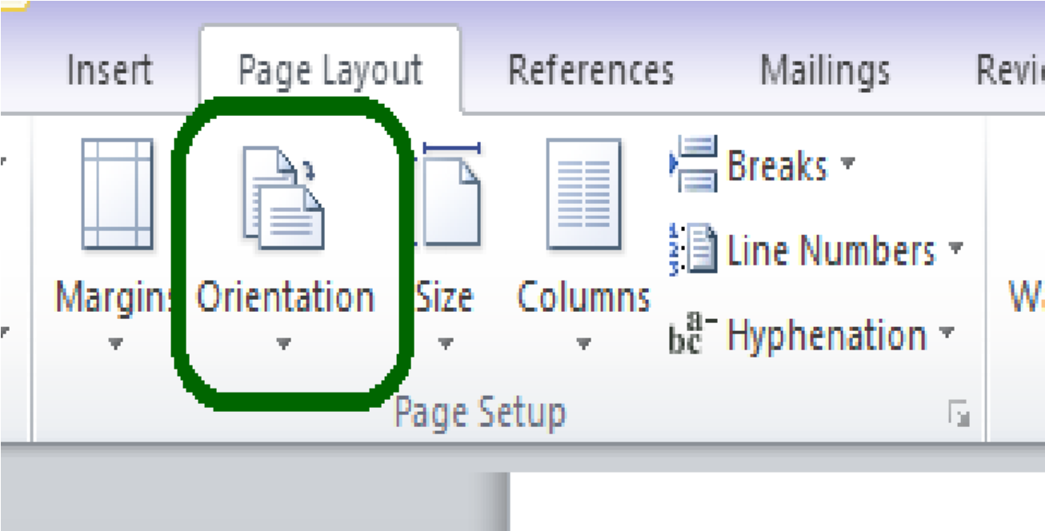

* **Page Size:** Select the paper size (e.g., A4, Letter).
* **Example:**

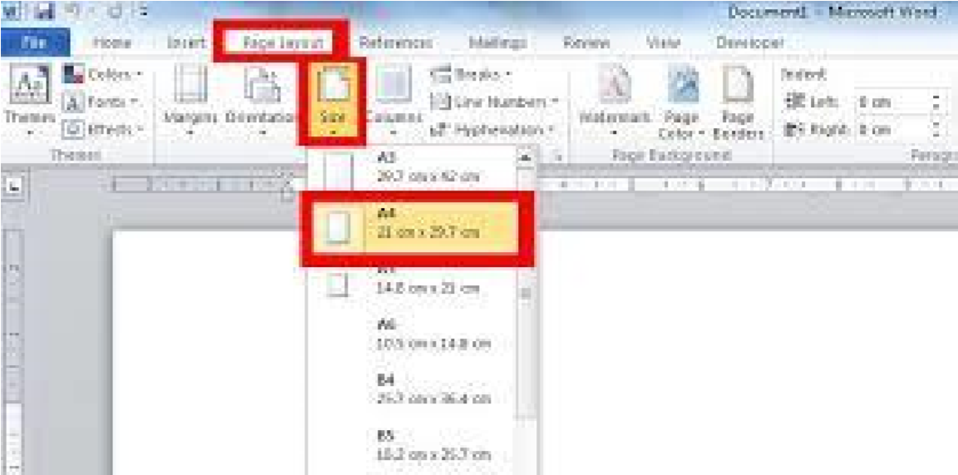

* **Headers and Footers:** Add headers and footers to pages, including page numbers, dates, and document titles.

**Example:**

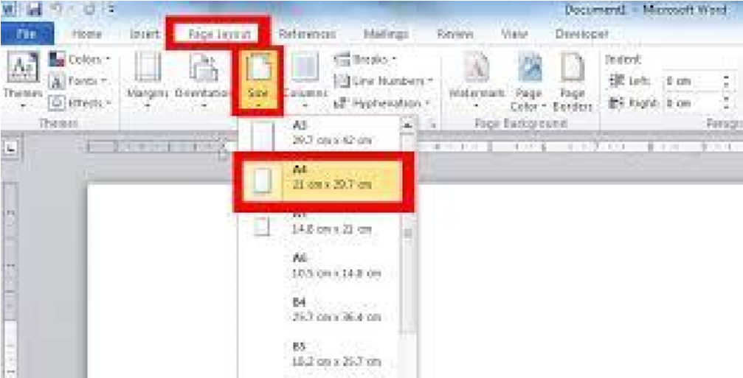

**Page Breaks:** Insert page breaks to start a new page.

* **Example**

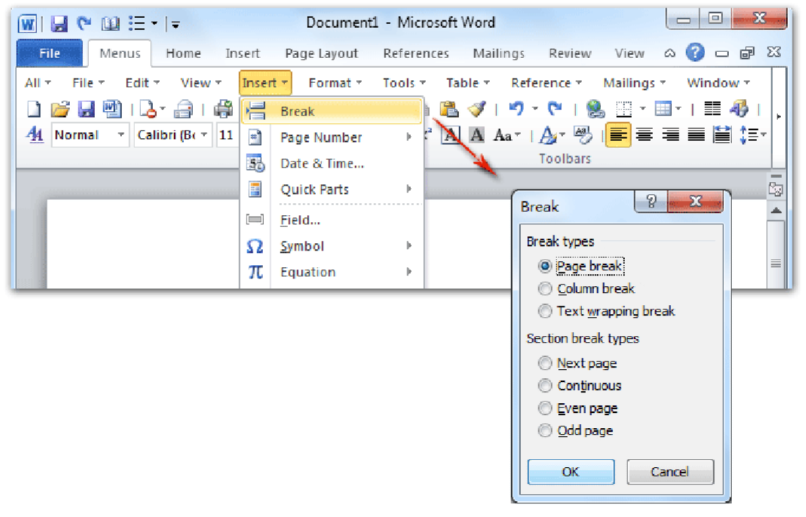

➢ **Inserting Elements:**

**Images:** Insert images from your computer or the web.

* 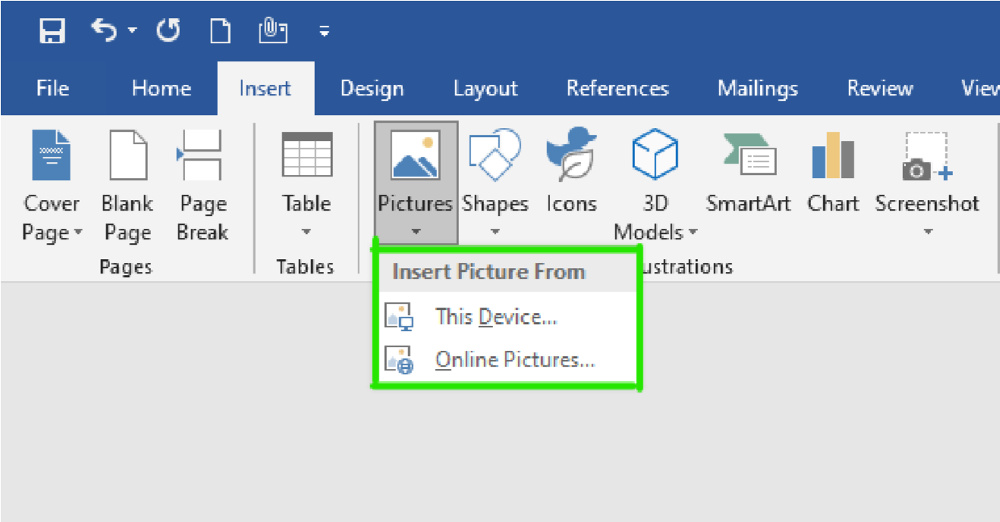

**Tables:** Create tables to organize data.

* **Example:**

* 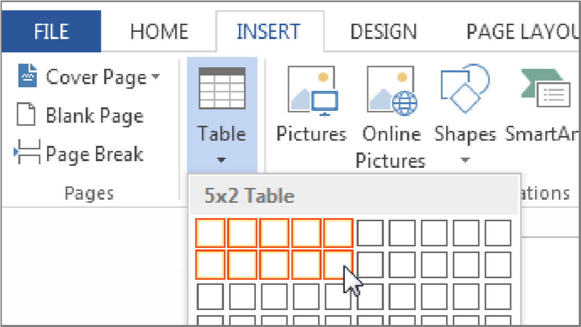

* **Shapes:** Insert shapes like rectangles, circles, and arrows.

***Example:***

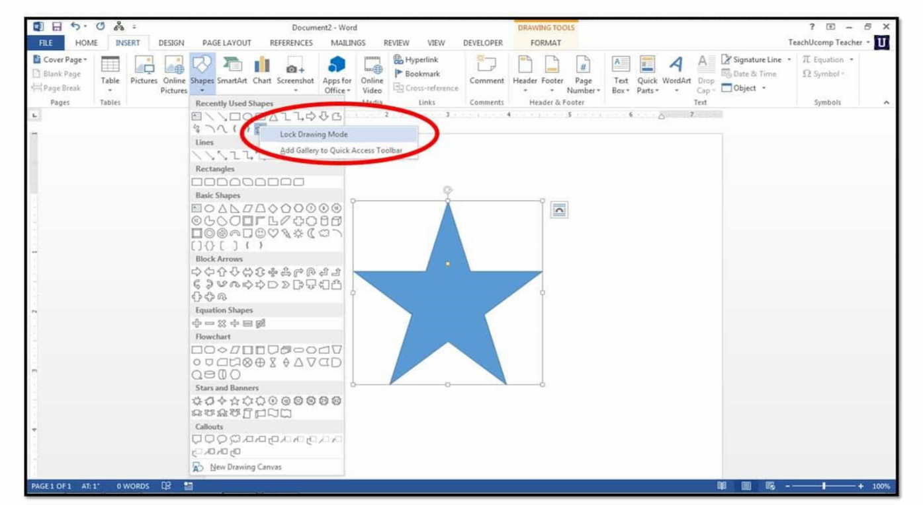

* **SmartArt:** Create diagrams and charts.

***Example:***

* **Hyperlinks:** Add links to websites or other documents.

➢ **Editing and Reviewing:**

* **Find and Replace:** Search for and replace specific text.
* **Example:**

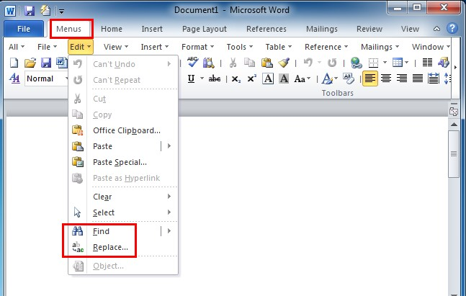

* **Spell Check and Grammar Check:** Identify and correct spelling and grammar errors
* **Track Changes:** Track changes made to a document.
* **Comments:** Add comments to specific parts of a document.
* **Reviewing Pane:** View and respond to comments.

➢ **Additional Features:**

* **Templates:** Use pre-designed templates to quickly create documents.
* **Example:**
* 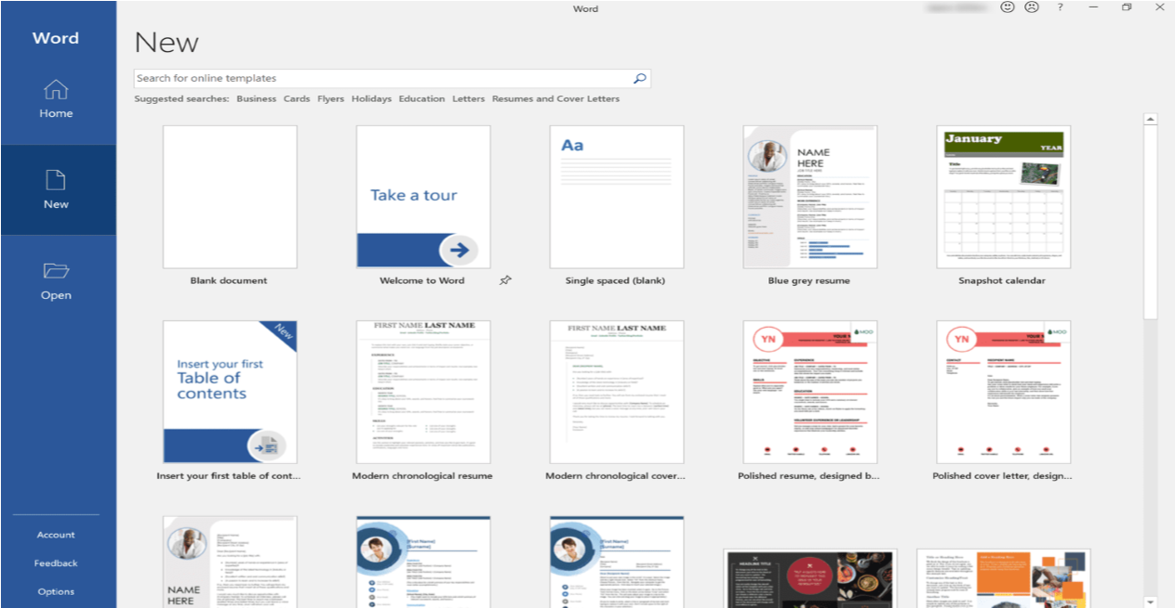

* **Mail Merge:** Create personalized documents, like letters or labels, using a data source.
* **Example:**
* 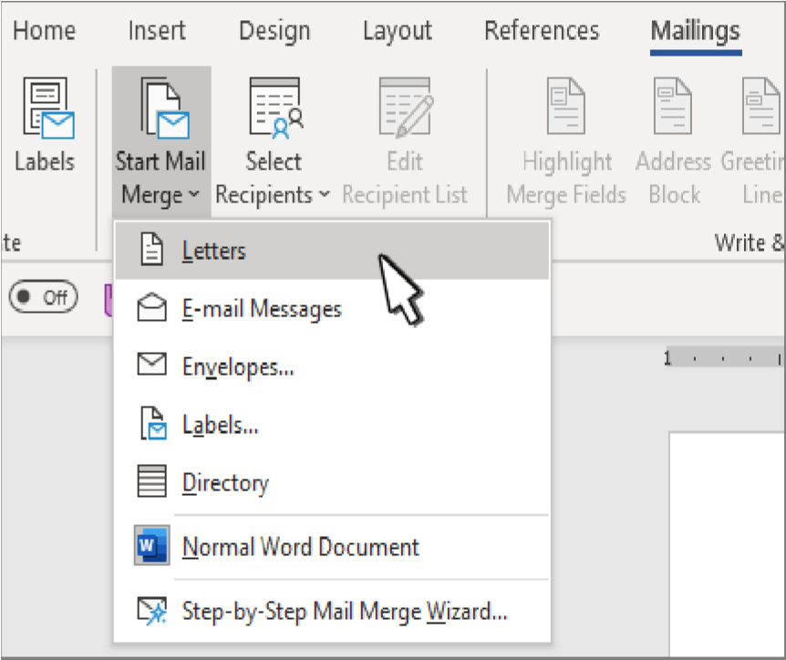

**Macros:** Record and automate repetitive tasks.

* **Example**

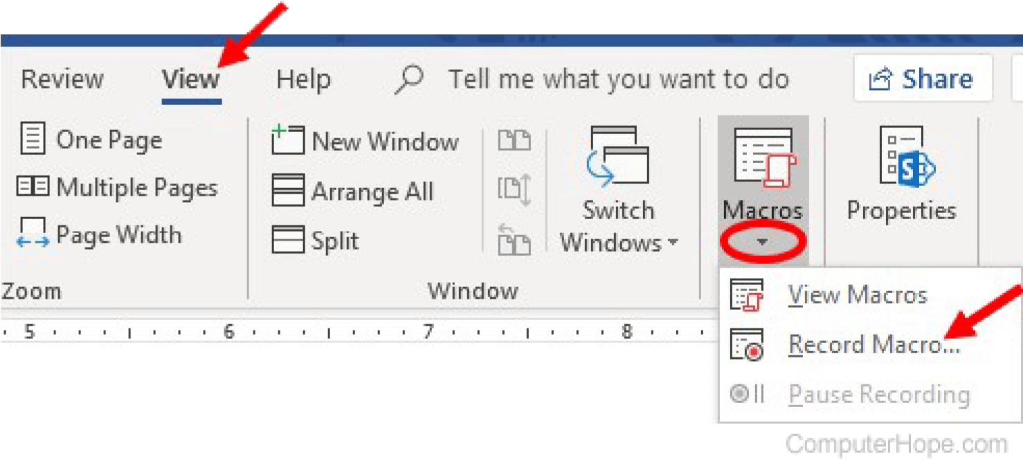

* **PDF Export:** Export documents as PDF files.
* **Example:**

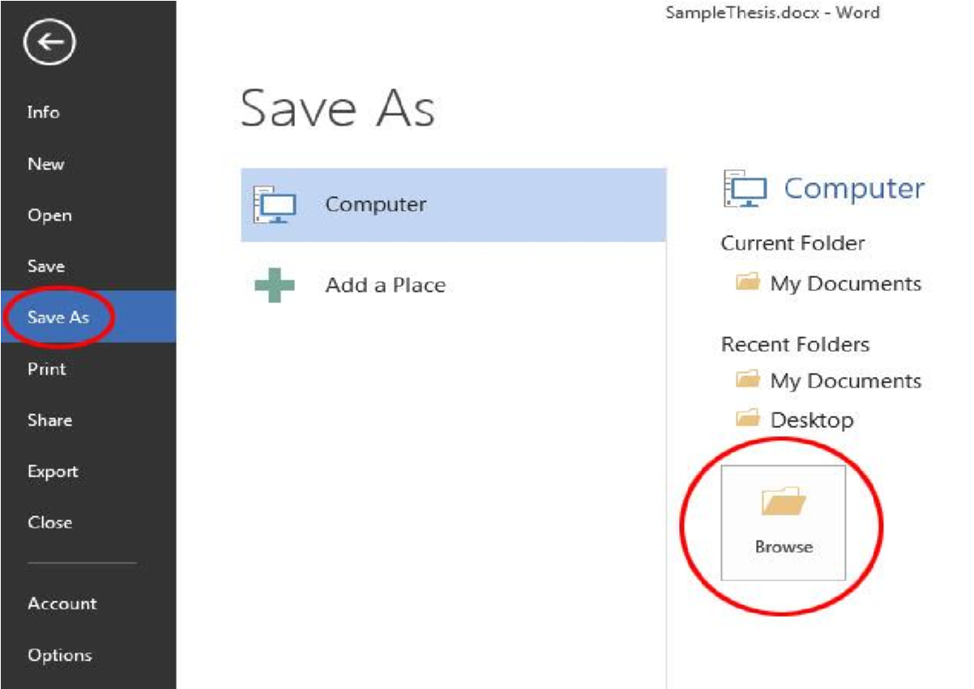

LAB 5

 **Mail Merge:**

**A Powerful Tool for Personalized Documents**

Mail merge is a feature in Microsoft Word that allows you to create personalized documents in bulk. It involves combining a main document with a data source to produce multiple documents, each customized with specific information from the data source.

➢ **Common Use Cases:**

* **Personalized Letters:** Create personalized letters to clients or customers.
* **Mailing Labels:** Generate mailing labels with addresses from a database.
* **Envelopes:** Print envelopes with recipient addresses.
* **Certificates:** Create personalized certificates with recipient names and other details.

➢ **Benefits of Mail Merge:**

Mail merge is a powerful feature used in word processing and spreadsheet applications to automate the creation of personalized documents such as letters, emails, labels, and envelopes. By integrating data from a source (e.g., a spreadsheet or database) into a template document, mail merge simplifies and streamlines the process of creating customized communication for large audiences. Here are the primary benefits of using mail merge:

**1. Time Efficiency**

* **Streamlined Process**:

Mail merge automates the process of personalizing individual letters or emails by inserting specific data fields (like names, addresses, or order details) into a template.

* **Bulk Processing**:

Instead of manually creating each document or email, a single template and data file can generate hundreds or thousands of personalized outputs, saving significant time. **Efficiency:**

* Saves time and effort by automating the creation of multiple documents.
* **Accuracy:**
* Reduces the risk of errors in manual data entry.
* **Professionalism:**
* Creates consistent and professional-looking documents.  **Table of contents:**

A table of contents (TOC) is a list of the sections or chapters within a document, along with their corresponding page numbers. It's like a roadmap that helps readers navigate through the document quickly and easily.

* **Key features of a table of contents:** 
  + **Organization:**
  + It provides a clear overview of the document's structure.
  + **Navigation:**
  + It allows readers to quickly locate specific sections.
  + **Clarity:**
  + It improves the readability and comprehension of the document

.➢ **How to create a table of contents:**

* 1. **Structure your document:** Organize your document into sections and subsections, using headings and subheadings.
  2. **Apply heading styles:** Assign appropriate heading styles to your sections and subsections.
  3. **Insert the table of contents:** Use your word processing software's built-in feature to automatically generate a table of contents based on the heading styles.
* **Section Breaks**

Section breaks are used to divide a document into separate sections. This allows you to apply different formatting, page numbering, headers, and footers to each section.

* **Next Page:** Starts a new section on the next page.
* **Continuous:** Starts a new section on the same page. Useful for changing the number of columns.
* **Odd Page:** Starts a new section on the next odd-numbered page.
* **Even Page:** Starts a new section on the next even-numbered page.
  + **References**

References are citations to sources used in your document. They can be in the form of footnotes, endnotes, or a bibliography. References help you give credit to the original authors and provide credibility to your work.

* + **Headers and Footers**

Headers and footers are areas at the top and bottom of a page where you can add text, images, page numbers, dates, or other information. They can be different for each section of your document.

Here are some common uses of headers and footers:

* **Page numbers:** Automatically number pages.
* **Running headers:** Repeat a title or heading on each page.
* **Dates:** Automatically insert the current date.
* **Author names:** Include author names on each page.

**Company logos:** Add a company logo to the header or footer. By effectively using section breaks, references, and headers and footers, you can create well-structured and professional-looking documents.

LAB 6 **MENDELEY:**

Mendeley Reference Manager is a free web and desktop reference management application. It helps you simplify your reference management workflow so you can focus on achieving your goals. With Mendeley

Reference Manager you can:

Store, organize and search all your references from just one

library.

**DIAGRAM:**

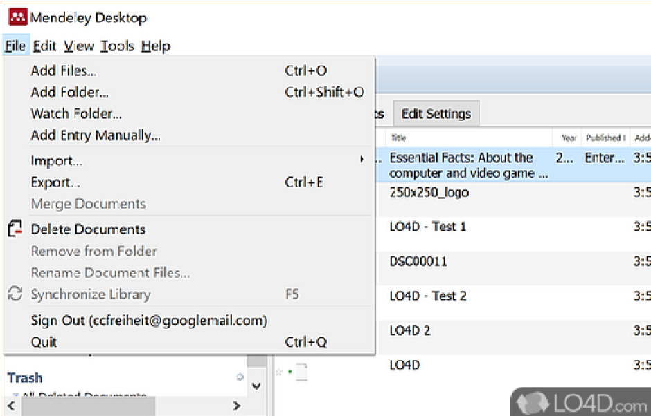

* **GRAMMARLY:**

Grammarly is an AI-powered writing tool that helps improve grammar, spelling, and writing style.

* **PDF Element:**

PDF element is a PDF editor and converter tool from Wondershare that allows users to read, edit, convert, annotate, sign, and share PDFs. It can help users produce high-quality PDF documents and forms quickly, affordably, and securely.

* **AUTOMATION WITH MACROS:**

Automation with macros creates and runs small programs that record and replay a sequence of actions to automate repetitive tasks:

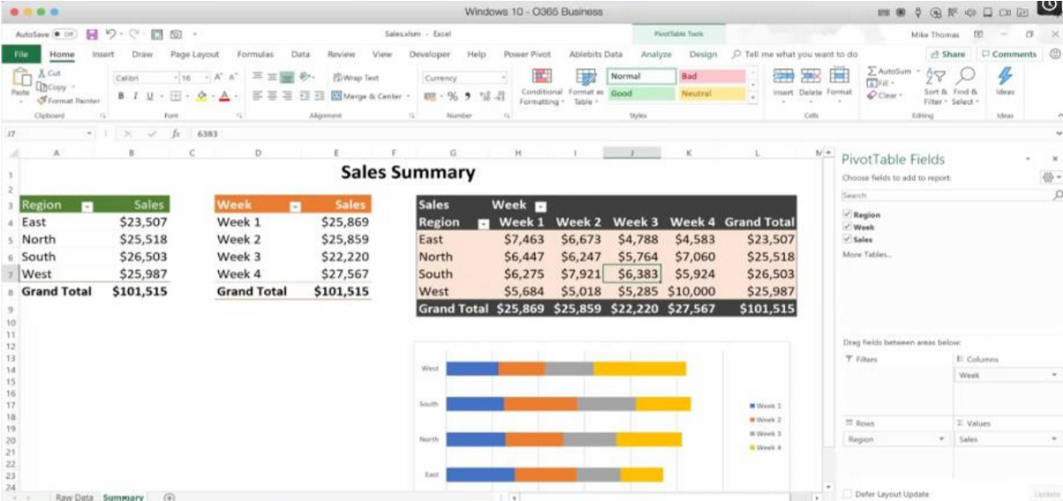

* **What macros are?**

Macros are small programs that record a series of actions, such as keystrokes and mouse clicks, to complete a task.

* **How macros are used?**

You can run a macro to replay the recorded actions with a single click To convert a PDF to a Word document, you can use Adobe Acrobat or a free online converter:

* **Adobe Acrobat**
  1. Open the PDF in Acrobat
  2. Select Convert from the global bar
  3. Select DOC from the drop-down menu next to Microsoft Word
  4. Select Convert to DOC
  5. Choose a location to save the file and select Save
* **Adobe Acrobat online converter**
  1. Select a PDF file
  2. Acrobat will automatically convert the file to a Word document
  3. Download your file
* Convert PDF to Word: A free online converter | Adobe Acrobat



Adobe

* **FOOTNOTES AND ENDNOTES:**

Footnotes and endnotes are both used to provide references, explanations, or comments for text in printed documents.

**REFRENCING TOOLS:**

Reference books and materials are research tools that provide quick information on a topic. Some types include encyclopedias, dictionaries, almanacs, and directories.

* **CITATIONS:**

A citation is a way to credit the original source of information, ideas, or images used in a research paper or other project.

**Some practical work that we do in our LAB**

New →ctrl+N open →ctrl+O

info→(tells us about privacy related to

created doc)

save →ctrl+S undo →ctrl+Y Redo →ctrl+Z print →ctrl+P cut →ctrl+X copy→ctrl+C paste →ctrl+V

Bold→ ctrl+B

Itallic→ ctrl+I

Underline→ ctrl+U

Center allign→ ctrl+E

Align left → ctrl+L

Align right→ ctrl+R

Format painter→ ctrl+shift+C Justified→ctrl+J

**function of random:**

Video provides a powerful way to help you prove your point. When you click Online Video, you can paste in the embed code for the video you want to add. You can also type a keyword to search online for the video that best fits your document.

To make your document look professionally produced, Word provides header, footer, cover page, and text box designs that complement each other. For example, you can add a matching cover page, header, and sidebar. Click Insert and then choose the elements you want from the different galleries.

Video provides a powerful way to help you prove your point. When you click

Online Video, you can paste in the embed code for the video you want to add.

You can also type a keyword to search online for the video that best fits your document.

To make your document look professionally produced, Word provides header, footer, cover page, and text box designs that complement each other. For example, you can add a matching cover page, header, and sidebar. Click Insert and then choose the elements you want from the different galleries.

Themes and styles also help keep your document coordinated. When you click **Desi~~g~~n an~~d~~ choose a new Theme, the ~~p~~ictures, charts, an~~d~~ Smart~~A~~rt ~~g~~ra~~p~~hics chan~~g~~e to match your new theme. When you a~~pp~~ly styles,**

Save time in Word with new buttons that show up where you need them. To change the way a picture fits in your document, click it and a button for layout options appears next to it. When you work on a table, click where you want to add a row or a column, and then click the plus sign.

Reading is easier, too, in the new Reading view. You can collapse parts of the document and focus on the text you want. If you need to stop reading before you reach the end, Word remembers where you left off - even on another device.

**Inserting a table:**  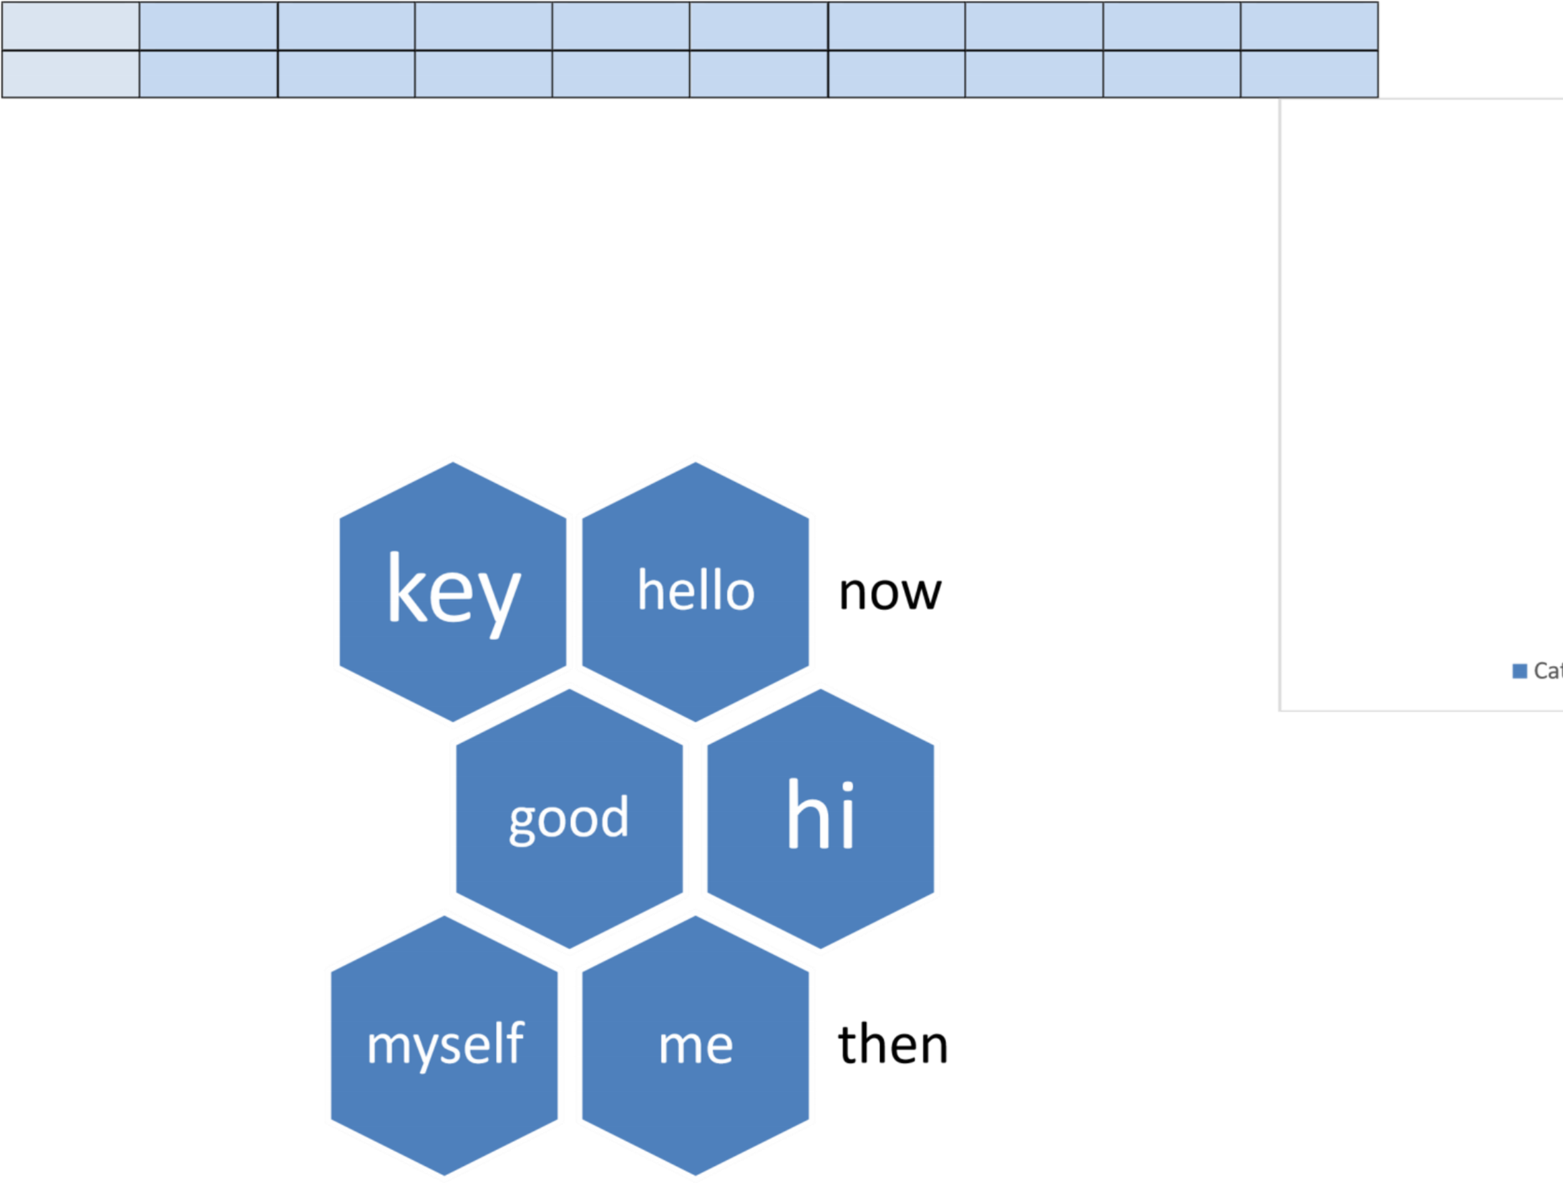tomorrow

**∫ 2**  𝑑 **x**



**A=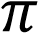R2**

**LAB 7**

 **Mail Management**

Mail management refers to organizing, sorting, and streamlining email communication. In professional settings, managing emails effectively can save time and improve productivity. Lab 7 teaches skills that help users efficiently deal with email overload by using tools and techniques like:

**DIAGRAM:**

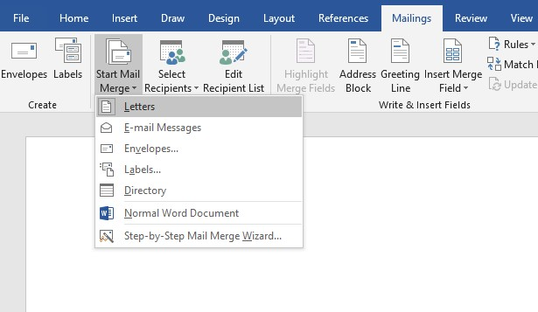

Based on the provided text, I can expand on each lab and create 1000word explanations for each one. Let me start with Lab 7 and proceed sequentially.

 **Mail Management**

Mail management refers to organizing, sorting, and streamlining email communication. In professional settings, managing emails effectively can save time and improve productivity. Lab 7 teaches skills that help users efficiently deal with email overload by using tools and techniques like:

**1.Email Categorization:**

•Learn to create and use folders or labels to organize emails based on projects, clients, or tasks.

•Use color codes or tags to prioritize emails that require immediate action.

**DIAGRAM:**

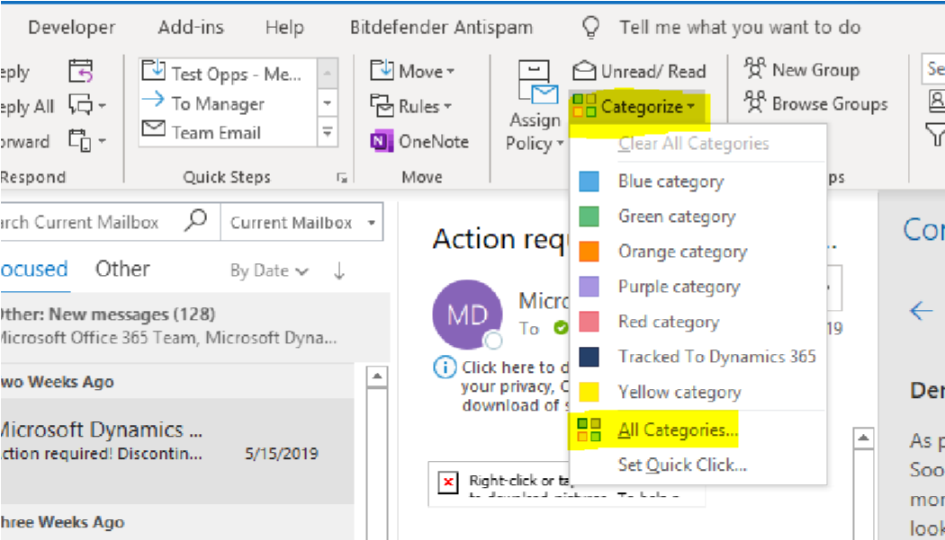

**2.Filtering and Sorting Emails:**

•Setting up automatic filters to sort incoming mail into predefined categories.

•Configuring email systems to identify spam, low-priority, or promotional messages.

**DIAGRAM:**

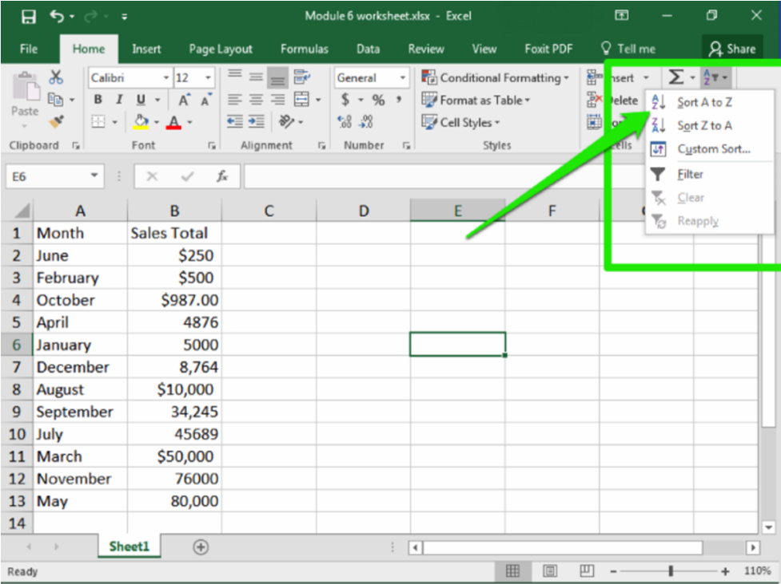

**3.Scheduling Emails:**

•Using features like “Send Later” in platforms such as Outlook or Gmail.

•Automating follow-ups to save time **DIAGRAM:**

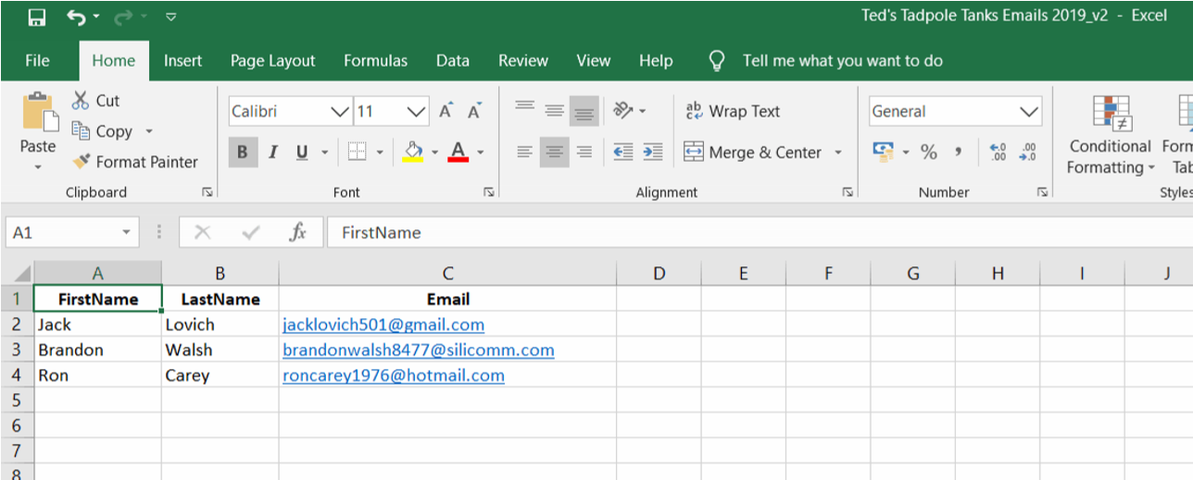

**4.Managing Attachments:**

•Understanding tools like cloud integration (One Drive, Google Drive) to share attachments without overloading inboxes.

•Learning how to compress files for efficient sharing.

**DIAGRAM:**

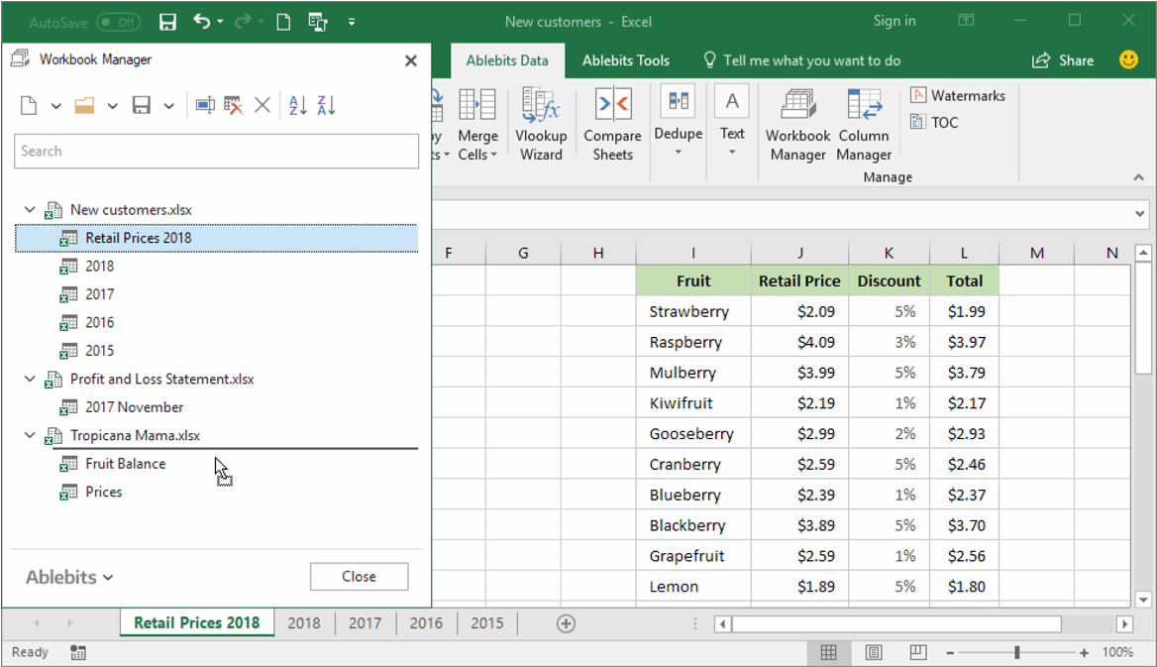

❖ **Collaborative Tools:**

Collaborative tools allow team members to work together on projects regardless of their physical location. The section in Lab 7 emphasizes tools that streamline communication and project coordination:

**1.Track Changes and Comments in Documents:**

•How to use tracking features in software like Microsoft Word to monitor edits made by team members.

•Adding comments for clarity and suggesting improvements. **FIGURE:**

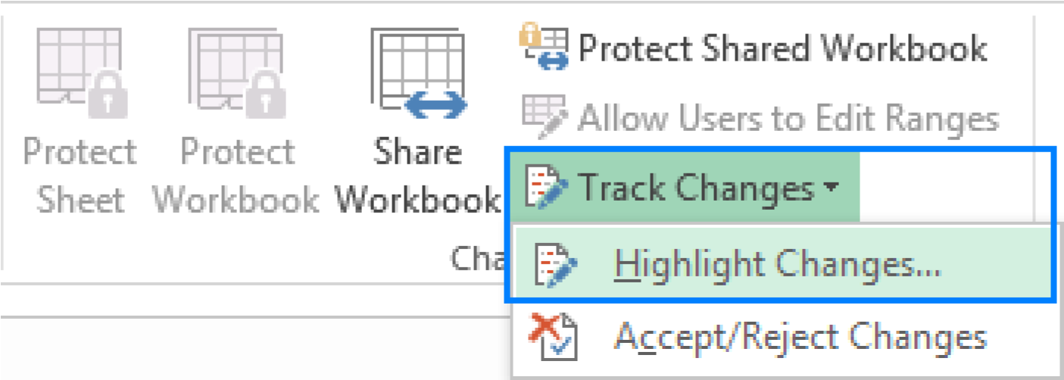

**2.Master Reviewing and Comparing Documents:**

•Techniques to compare multiple versions of a document and identify changes.

•Using software to merge changes from different collaborators. **FIGURE:**

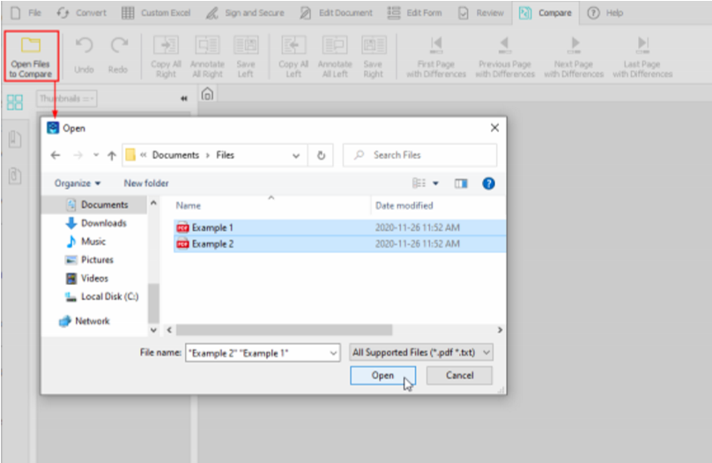

**3.Shared Workspaces:**

•Using cloud-based tools like Google Workspace or Microsoft 365 for realtime document editing.

•Features like version history to restore previous edits if errors occur. **FIGURE:**

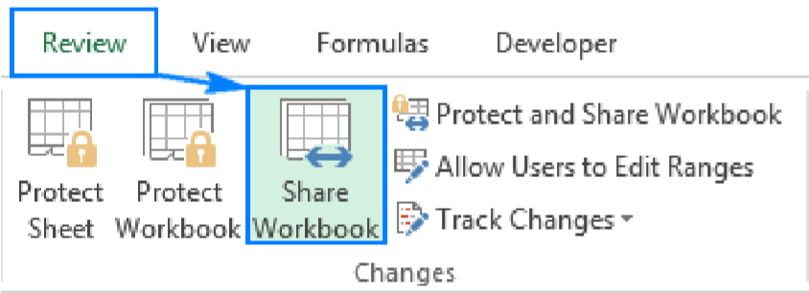

**4.Video and Chat Tools:**

•Integration of tools like Microsoft Teams, Zoom, or Slack for instant communication.

•Features such as screen-sharing and collaborative whiteboards.

**FIGURE:**

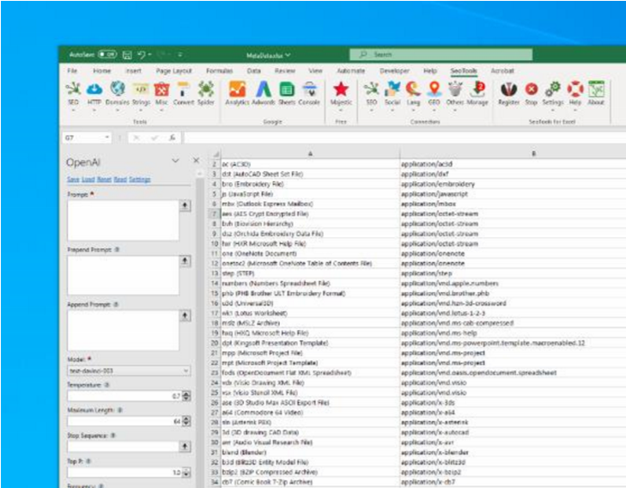

 **Document Protection:**

With the increase in cyber threats, securing sensitive documents has become a necessity. Lab 7 focuses on methods to ensure the safety and integrity of digital files. Key practices include:

**1.Password-Protected Documents:**

•Steps to create passwords for Word, Excel, and PDF files.

•Guidelines on creating strong passwords that are difficult to crack. **FIGURE:**

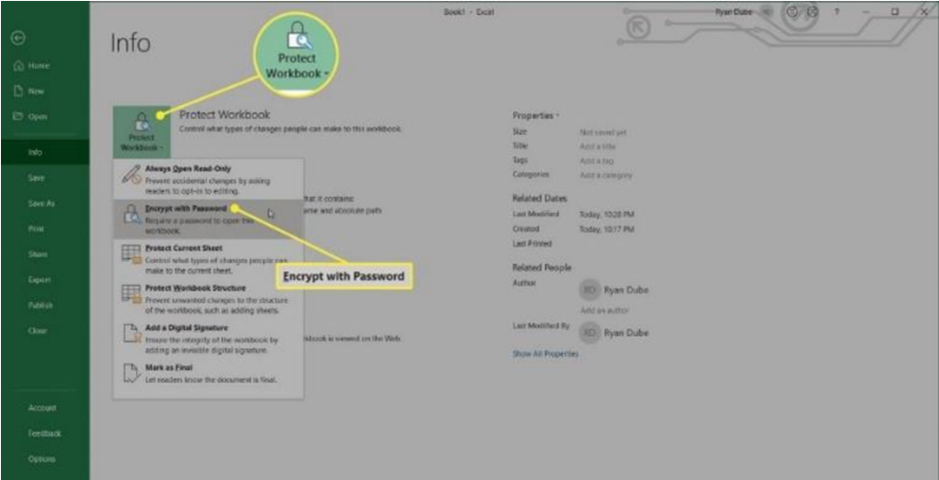

**2.Controlling Editing Permissions:**

•Assigning roles to collaborators, such as “Viewer,” “Commenter,” or “Editor.”

•Restricting access to sensitive sections of a document.

**FIGURE:**

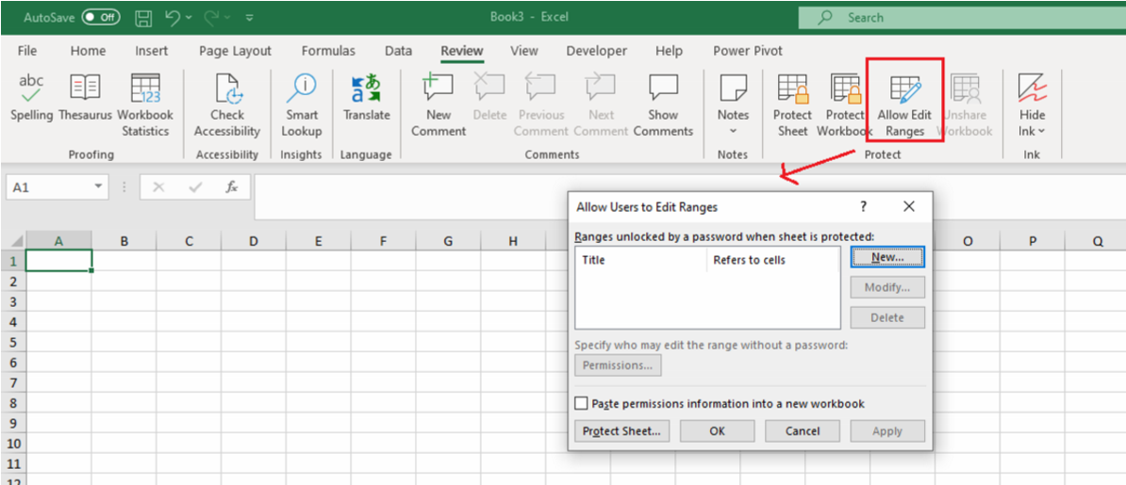

**3.Encryption:**

•Basics of encrypting documents for added security.

•Introduction to tools like BitLocker and third-party encryption software. **FIGURE:**

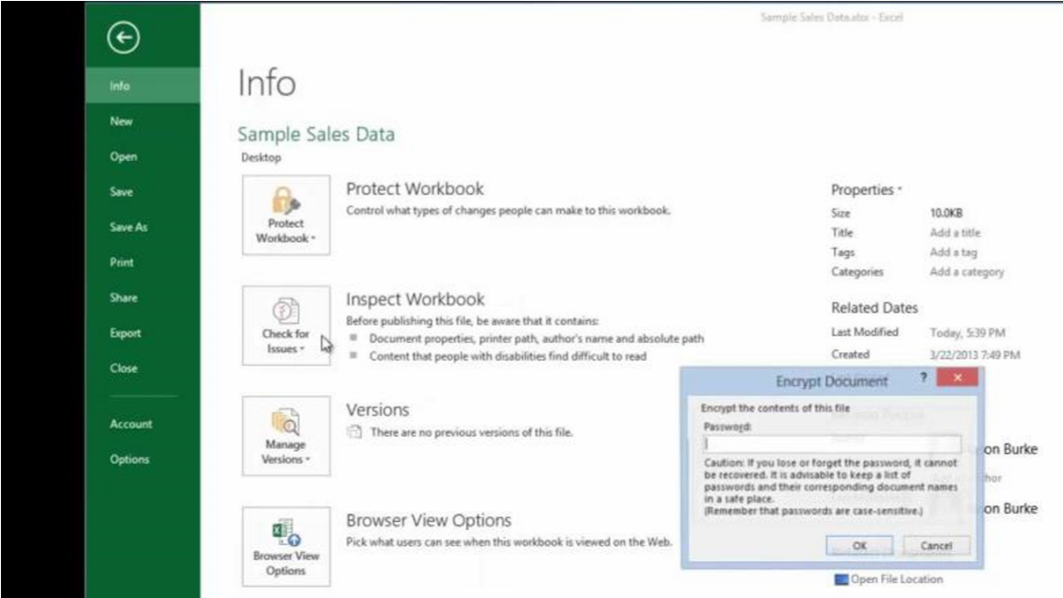

**4.Backing Up Documents:**

•Using cloud services like Google Drive or Dropbox for automatic backups.

•The importance of regular backups to prevent data loss.

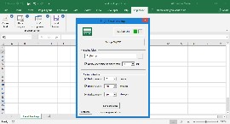

**LAB 8**

 **Introduction to Excel and Basic Skills**

Excel is one of the most widely used tools for data management and analysis. In Lab 8, learners are introduced to the basic skills and features of Excel, including formulas, functions, and data sorting/filtering. Here is a detailed breakdown of the lab:

**Introduction to Excel**

Excel provides users with a platform to organize data, perform calculations, and generate reports. Lab 8 starts with an overview of the Excel interface, including:

**1.Excel Worksheets and Workbooks:**

•Understanding the difference between a single worksheet and a workbook containing multiple sheets.

•Learning how to navigate between sheets and rename, insert, or delete them.

**EXAMPLE:**

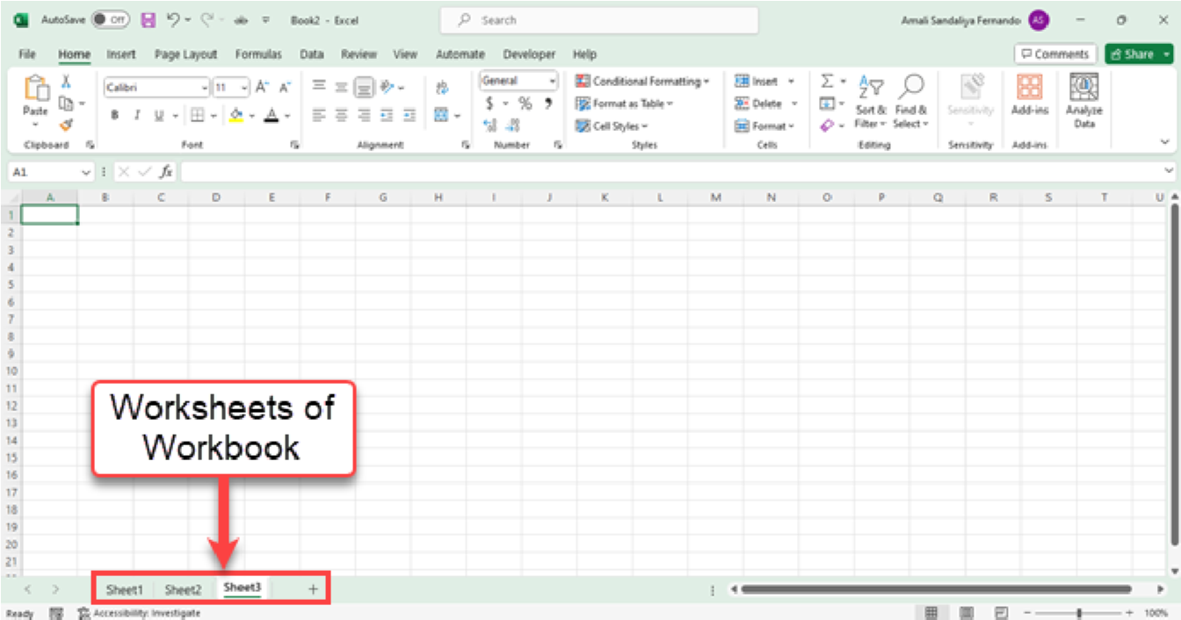

**2.Interface Overview:**

•Familiarity with the ribbon, toolbar, and common commands.

•Customizing the toolbar for quick access to frequently used features. **FIGURE:**

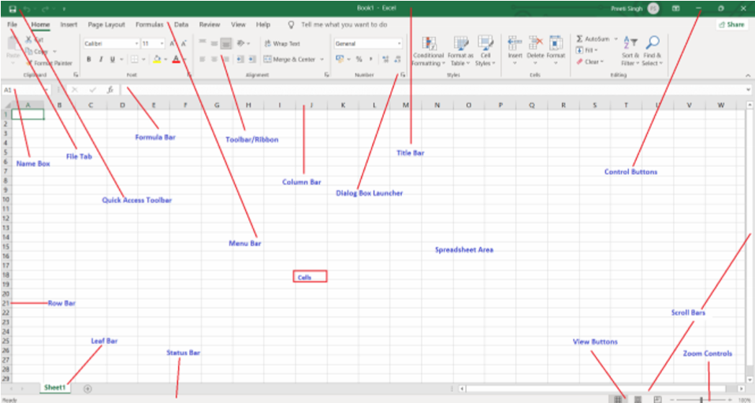

❖ **Basic Formulas and Functions**

Formulas and functions are the backbone of Excel. Lab 8 introduces the most commonly used ones:

**1.Basic Mathematical Operations:**

•Adding, subtracting, multiplying, and dividing using formulas.

•Combining formulas with cell references for dynamic calculations.

**2.Common Functions:**

**•MIN/MAX:**

Finding the smallest or largest value in a dataset.

**•COUNT:**

Counting the number of cells that contain numbers.

**•IF Statements:**

Creating logical tests to return specific results based on conditions.

**3.Working with Multiple Worksheets:**

•How to reference cells from other sheets within the same workbook.

•Organizing related data across multiple sheets.

**FIGURE:**

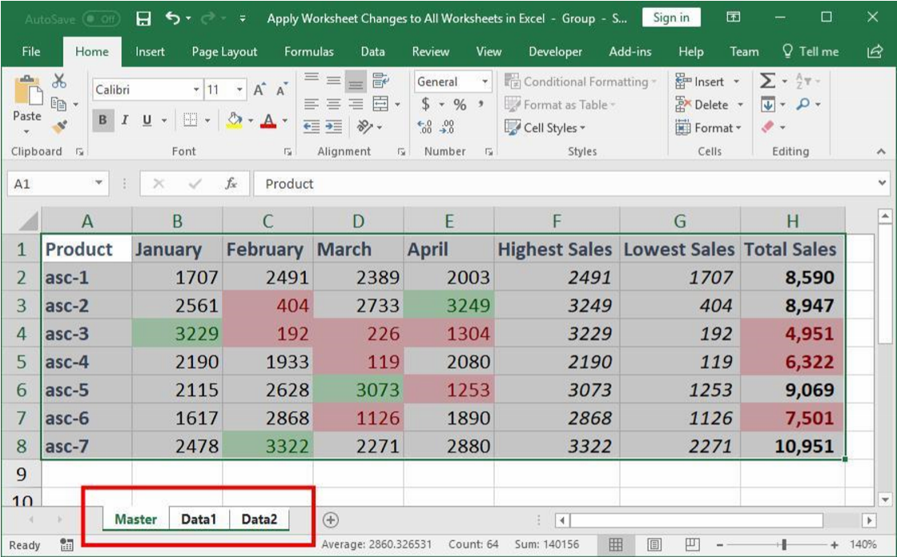

❖ **Introduction to Cell Referencing**

Cell referencing is a crucial skill in Excel that allows users to create dynamic formulas:

**1.Relative Referencing:**

•Adjusting cell references automatically when formulas are copied to other cells.

•Examples include summing rows or columns with a formula like =SUM(A1:A10) **EXAMPLE:**

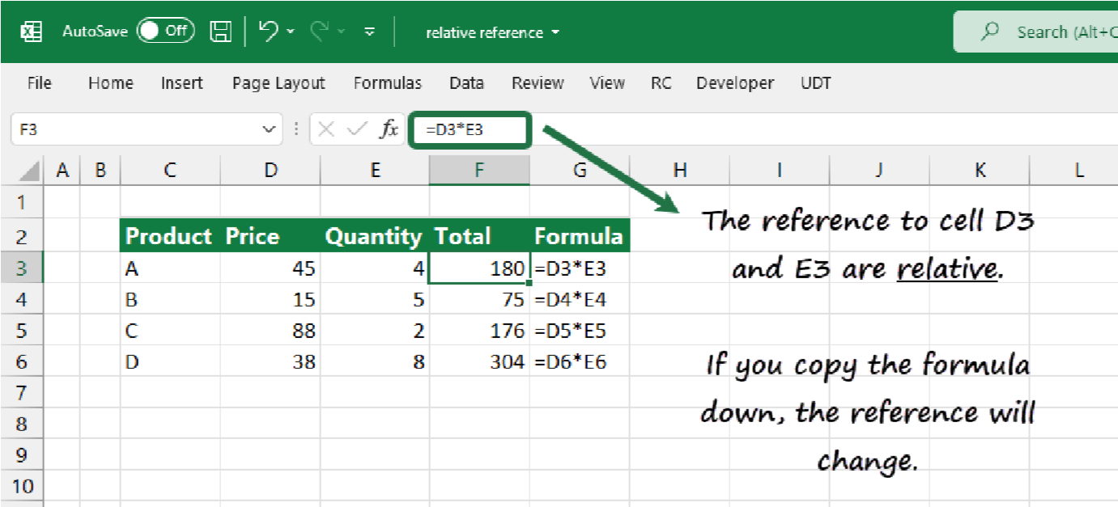

**2.Absolute Referencing:**

•Locking specific cells in formulas using $ (e.g., $A$1).

•Practical applications include interest rate calculations and fixed multiplier formulas.

**EXAMPLE:**

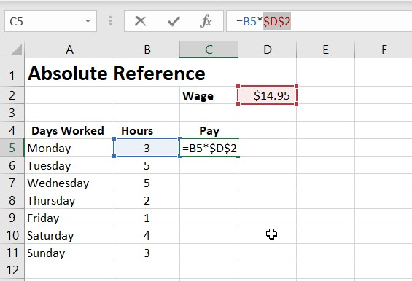

**3.Mixed Referencing:**

•Partially locking rows or columns (e.g., $A1 or A$1) for specific use cases. **EXAMPLE:**

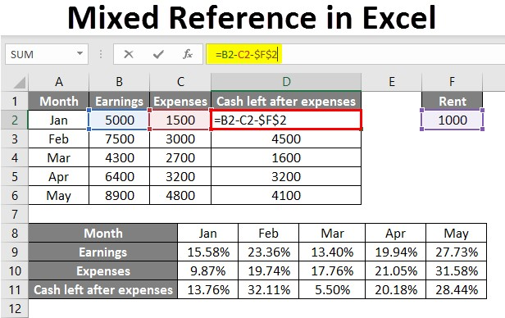

❖ **Sorting and Filtering Data**

Sorting and filtering are essential for organizing and analyzing data:

**1.Sorting:**

•Arranging data in ascending or descending order based on one or more criteria.

•Multi-level sorting to prioritize data.

**EXAMPLE:**

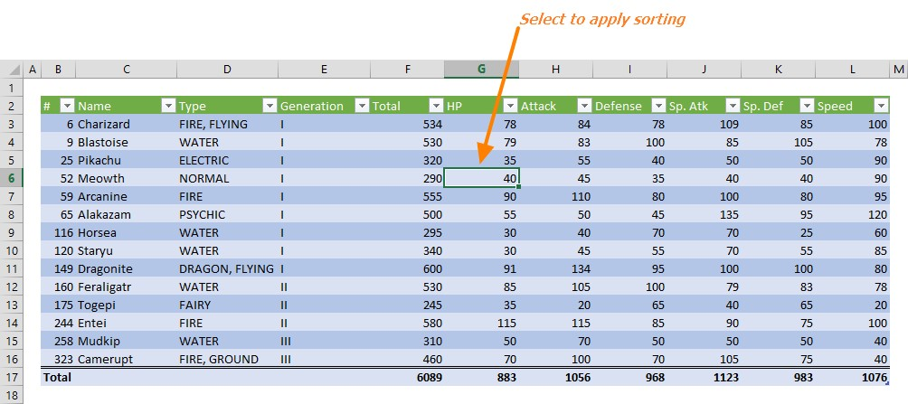

**2.Filtering:**

•Displaying only the rows that meet certain conditions using filters.

•Creating custom filters to refine datasets.

**EXAMPLE:**

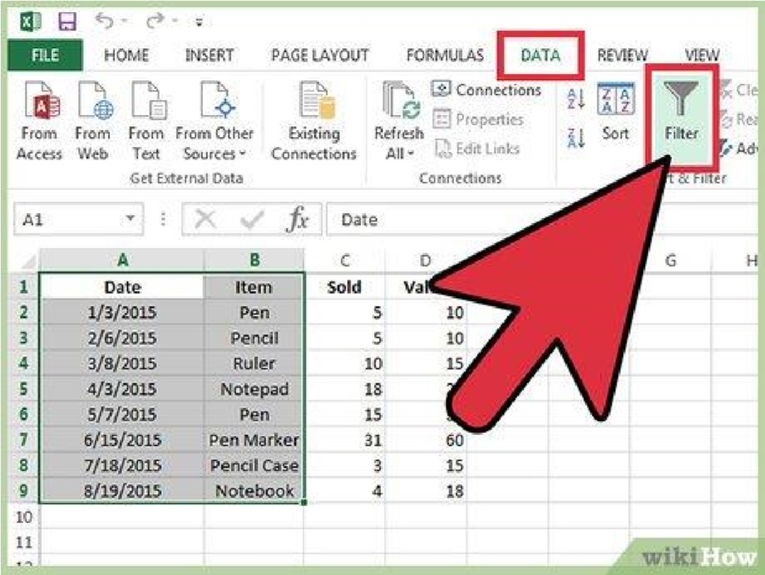

**LAB 9**

 **Data Visualization and Advanced Features**

Data visualization transforms raw data into meaningful insights. Lab 9 covers creating charts, conditional formatting, and working with advanced Excel features like QR codes and barcodes.

❖ **Creating Charts and Graphs**

Excel offers a range of chart options to represent data visually:

**1.Bar Charts**:

•Displaying comparisons between different categories.

•Adding axis labels, data labels, and formatting options.

**EXAMPLE:**

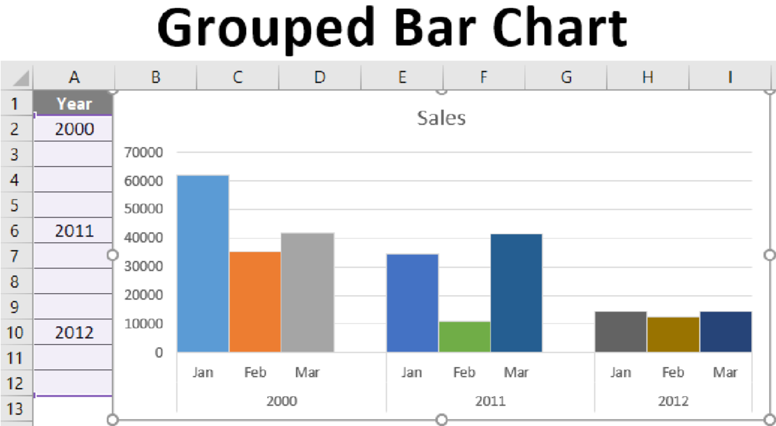

**2.Line Graphs:**

•Ideal for showing trends over time.

•Customizing line styles and adding markers.

**EXAMPLE:**

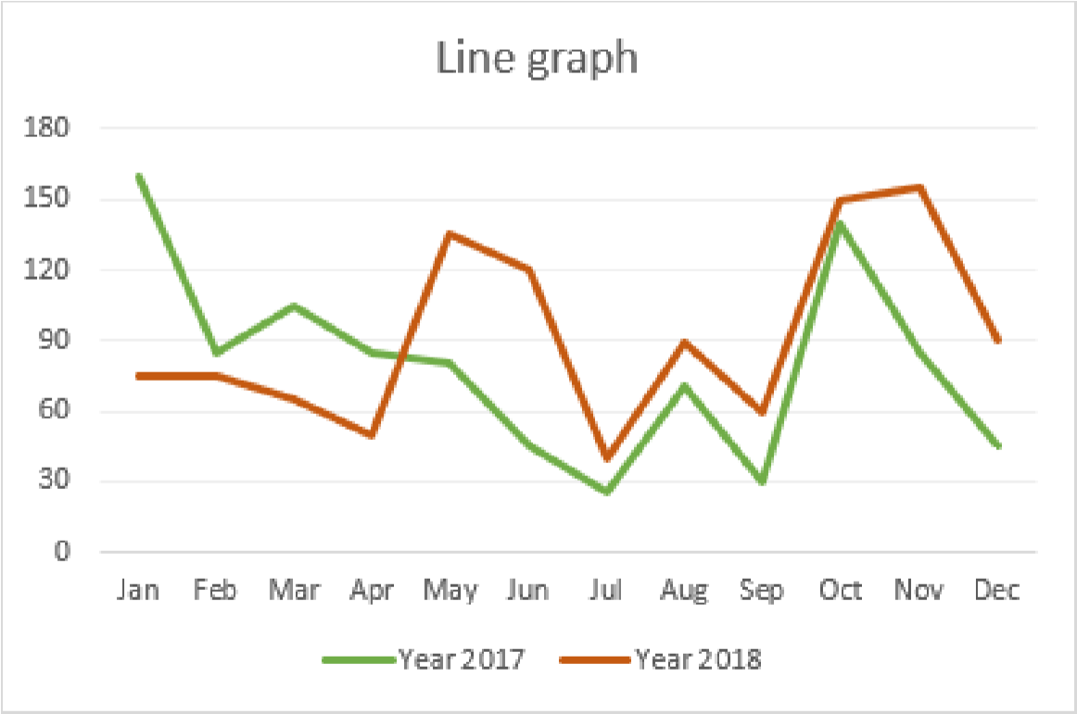

**3.Pie Charts:**

•Representing proportions and percentages.

•Exploding slices for emphasis.

**EXAMPLE:**

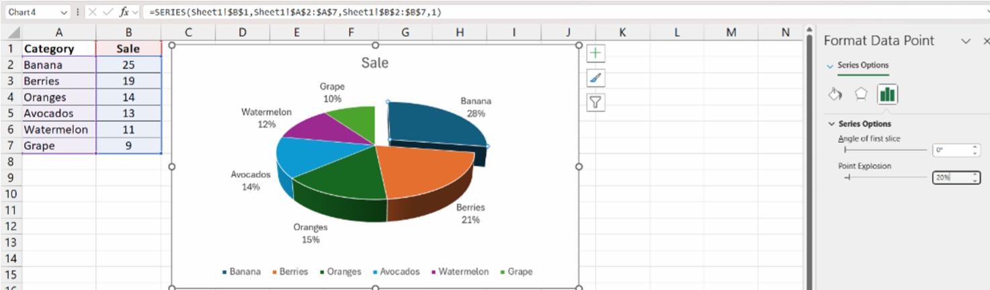

* **Conditional Formatting**

Conditional formatting highlights data based on rules:

**1.Color Coding:**

•Applying colors to cells based on values.

•Examples include highlighting cells greater than a certain value.

**EXAMPLE:**

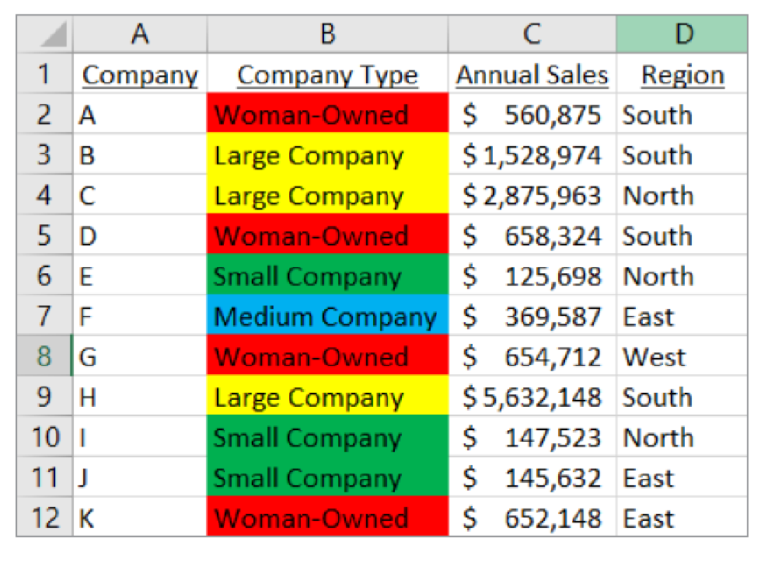

**2.Data Bars and Icon Sets:**

•Adding visual indicators like bars or arrows to represent data magnitude. **EXAMPLE:**

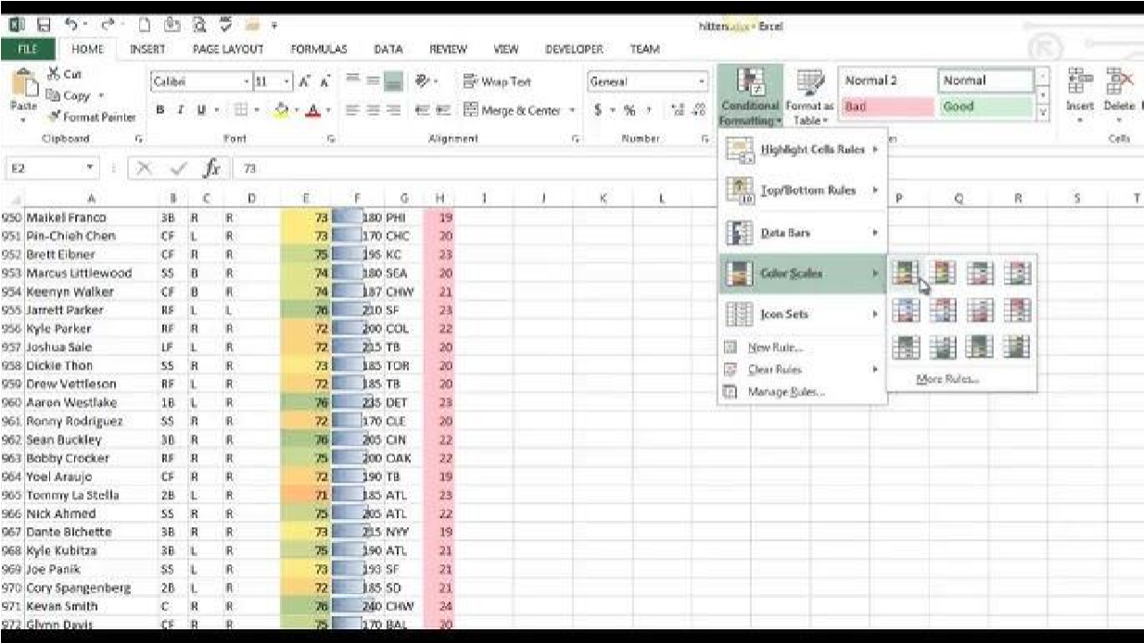

* **Creating Barcodes and QR Codes**

Barcodes and QR codes are increasingly used in business settings. Lab 9 teaches:

**1.Barcode Creation:**

•Using Excel add-ins or formulas to generate barcodes.

•Formatting cells for barcode display.

**EXAMPLE:**

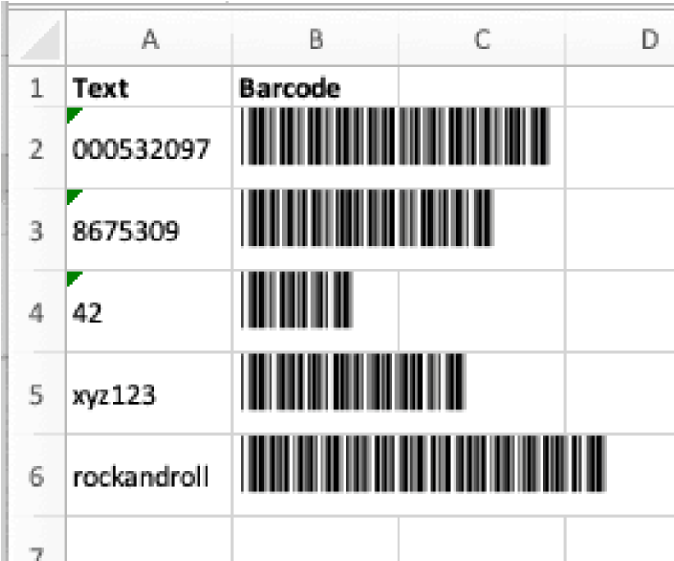

**2.QR Code Creation:**

•Steps to generate QR codes using free tools or plugins.

•Embedding codes into reports.

**EXAMPLE:**

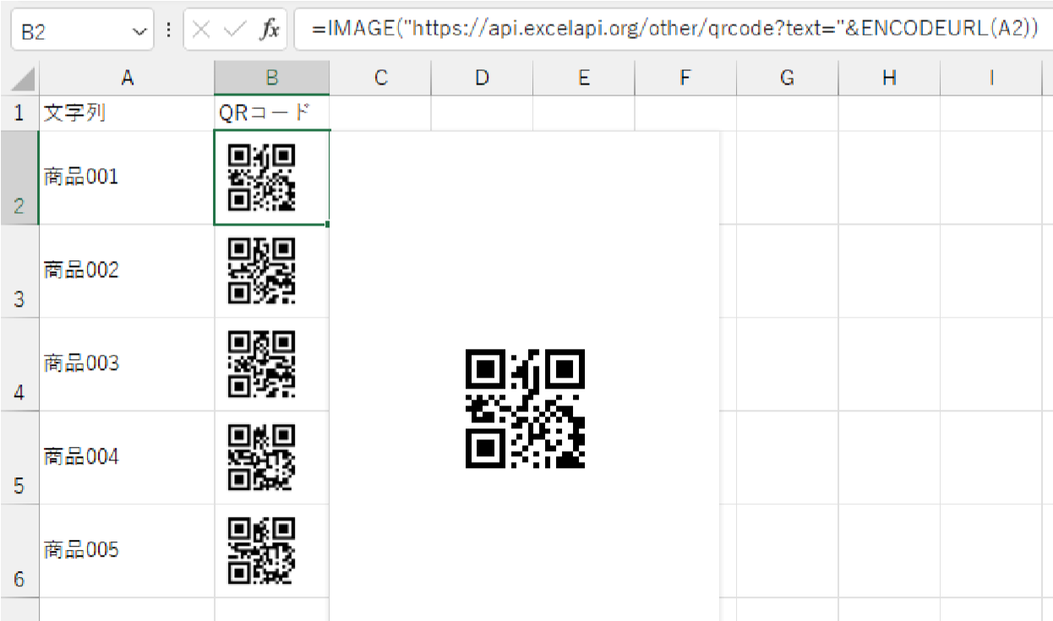

**LAB 10**

 **Advanced Tools and Final Project**

Lab 10 focuses on advanced Excel features and culminates in a final project that tests all the skills learned ❖ **Pivot Tables**

Pivot tables allow users to summarize large datasets quickly:

**1.Creating Pivot Tables:**

•Dragging and dropping fields to generate summaries.

•Adding filters, columns, and rows.

**EXAMPLE:**

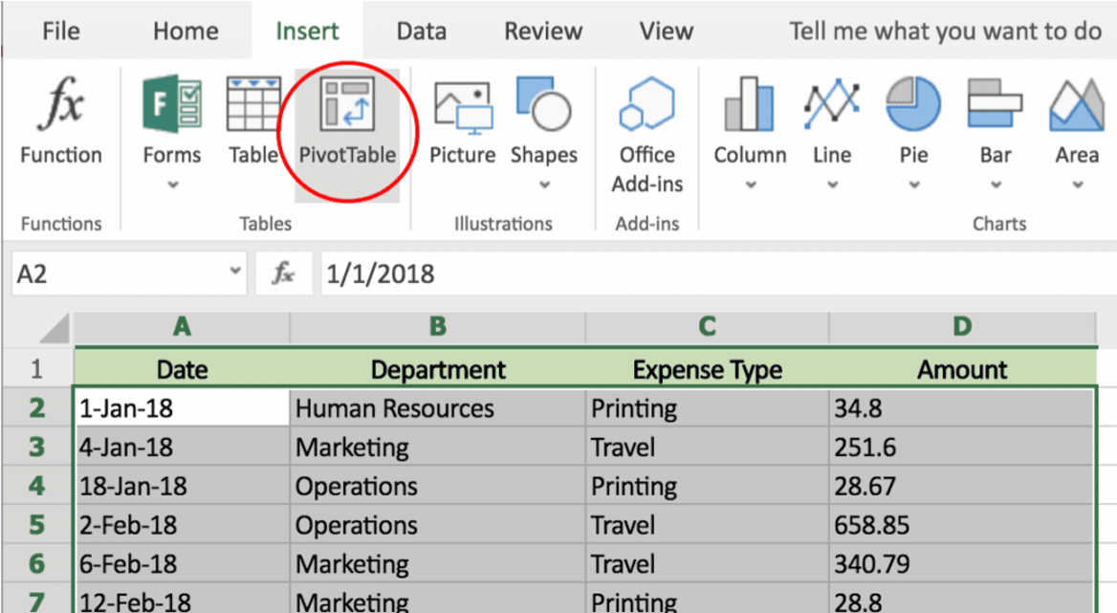

**2.Analyzing Trends:**

•Calculating totals, averages, and percentages.

**EXAMPLE:**

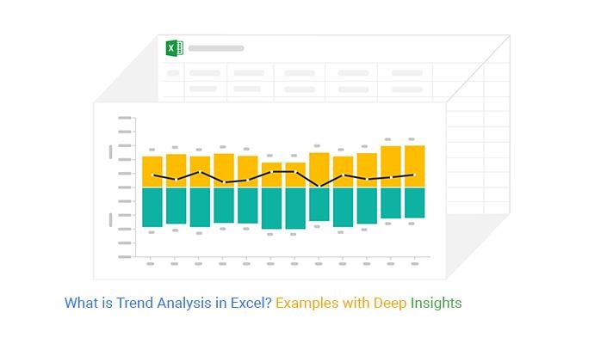

* **VLOOKUP and HLOOKUP**

Lookup functions simplify data retrieval.

**1.VLOOKUP:**

•Searching for values vertically in a table.

•Practical applications include retrieving product details based on IDs.

**EXAMPLE:**

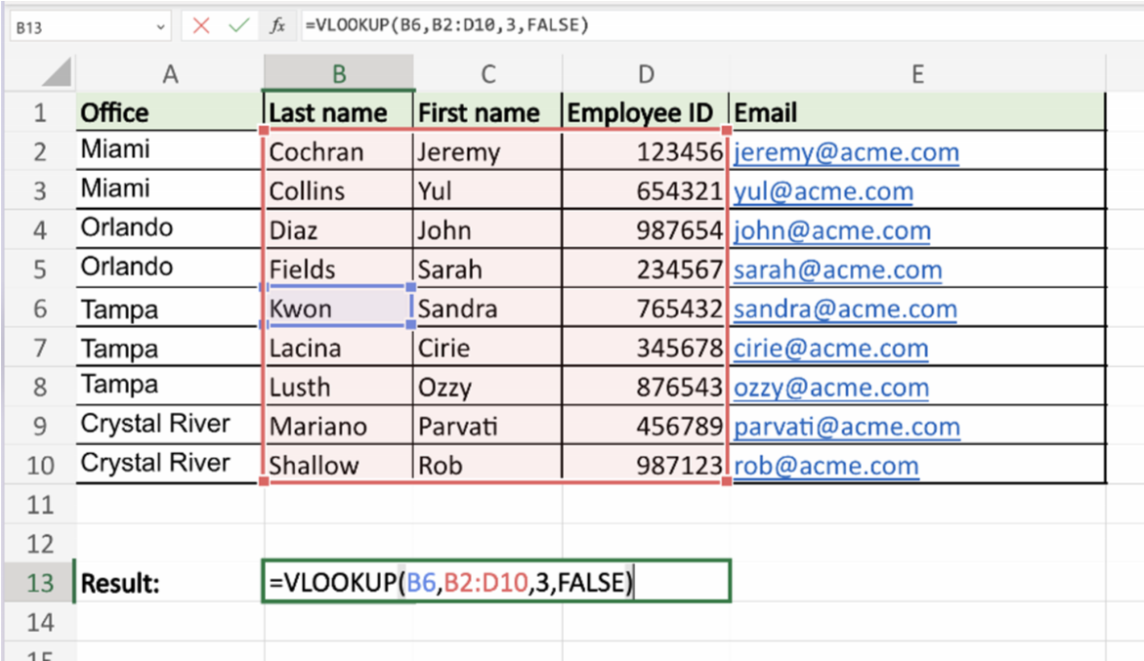

**2.HLOOKUP:**

•Similar to VLOOKUP but searches horizontally.

**EXAMPLE:**

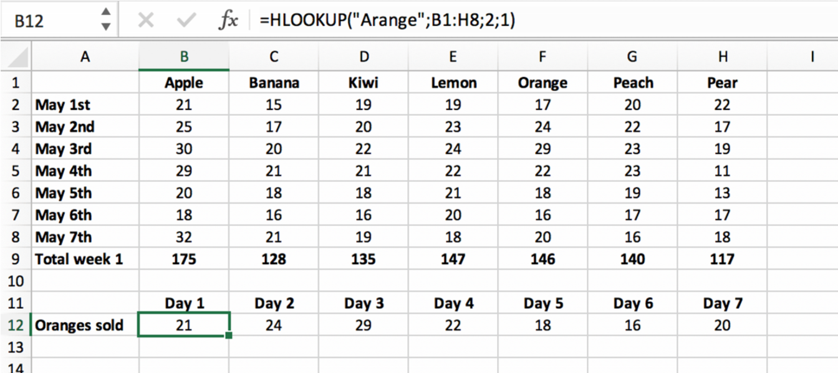

* **Introduction to Macros**

Macros automate repetitive tasks in Excel:

**1.Recording Macros:**

•Capturing user actions to create automated workflows.

•Assigning macros to buttons for ease of use.

**EXAMPLE:**

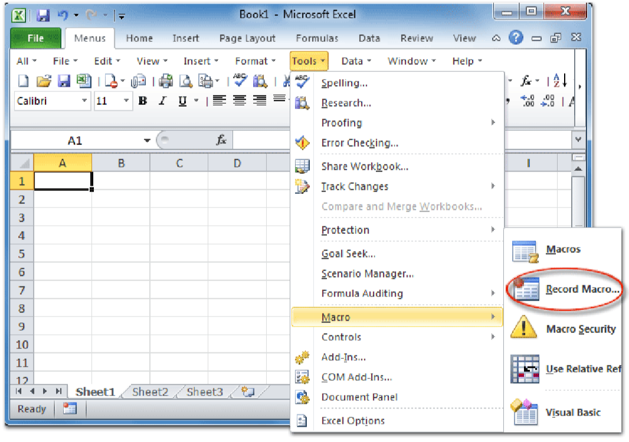

* Final Project

The final project integrates all concepts learned in Labs 7–10:

**1.Analyzing and Visualizing Data:**

•Importing raw data and applying formulas.

•Creating charts, conditional formatting, and summaries.